**MAHARAJA SURAJMAL INSTITUTE**

Affiliated to GGSIP University & NAAC 'A' grade accredited.



DEPARTMENT OF COMPUTER APPLICATIONS

**WEB TECHNOLOGIES**

PRACTICAL FILE

SUBJECT CODE- BCA 254

SUBMITTED BY:                           SUBMITTED TO:

Name: Harshit Sharma                   Dr. Menal Dahiya

Enroll no: 03621202019      Associate Professor,MSI Sem: 4th   Sec: 2nd shift

|  |  |
| --- | --- |
| S. No | Contents |
|  | Create your C.V. using various basic HTML tags. |
|  | Create a web page with following specifications:   1. an ordered list containing name of your friends. 2. an unordered list specifying hobbies. 3. some links to various search engines. 4. links to five different web pages, created by you, opening in new window. 5. a link at the top of page so that when clicked jump all way to the bottom of page. 6. a link at the bottom of page so that when clicked jump all way to the top of page. |
|  | Create the following unordered/ordered nested list as shown in figure. |
|  | Create the Time-table of your class using HTML tags. |
|  | Create the following table as shown using HTML. |
|  | Create a web page using 3 frames and link them to an image, audio and video as shown in figure. |
|  | Create a web page having 6 frames and link each frame with 5 different web pages. |
|  | Create the following frameset as shown in figure. |
|  | Create the following form in HTML as shown in figure. |
|  | Create an online application form having following specifications:   1. position applied for(autofocus), name, nationality, gender, date of birth (selected from auto picked of a text area), address, telephone number and email(required), password(required). 2. Educational history, qualifications and skills(checkbox). 3. Work experience/employment/training in terms of employer history and number of years of experience selected from a slider. Set max. years of experience to 10 years. 4. personal statement. 5. two referees including names, occupation, relationship, address, telephone. 6. a submit and clear button. |
|  | Create an Iframe and write some lines before and after it. |
|  | Create a web page showing India’s map and create hotspots on five different states and link them to the e-government sites of the respective states. |
|  | Create the following page using CSS as shown in figure. |
|  | Create a CSS Zebra Striping a table. |
|  | Create a CSS based button. |
|  | Use two images and using CSS transition properties on hover change one to another. |
|  | Write about incredible India using external stylesheet. |
|  | Write a program demonstrating all operators of JS. |
|  | Write a JS program to find:   1. factorial of number 2. prime numbers in a range 3. reverse of a number |
|  | Write a JS program to wish user at different hours of a day. |
|  | Prompt a user for the cost price and selling price of an article and output the profit and loss percentage. |
|  | Write a JS program to input a string from the user and abbreviate it. |
|  | Write a JS program to show mouse event handling. |
|  | Write a program to show the use of objects in JavaScript. |
|  | Write a script that takes 3 integers from user and display sum, average, product, largest and smallest in alert box. |
|  | Write a JS program to demonstrate setTimeout function. |
|  | Write a JS program to sort an array. |
|  | Write a JS program to capitalize first letter of a string. |
|  | Write a JS program to demonstrate blur, focus and reset event. |
|  | Write an event bubbling program in JavaScript. |
|  | Write a JS program to prompt the user to enter and change the style of ordered list using switch statement. |
|  | Write a program to demonstrate all the following filters on an image:  (a)Blur (b)Brightness (c)Contrast (d)Drop-shadow (e)Grayscale (f)Hue-rotate (g)Invert  (h)Opacity (i)Saturate (j)Sepia (k)Flip |
|  | Write the code for placing different elements on webpage using static and fixed positioning. |
|  | Write the code for placing different elements on webpage using absolute and relative positioning. |
|  | Create a webpage to implement ‘this’ keyword for changing the color of heading at run- time. |
|  | Write a program to change heading color and display a list at run time based on onclick event. |
|  | Create a webpage displaying the usage of Image Rollover effect by making use of Id. |
|  | Create a webpage to apply different presentation effects using blend transition. |
|  | Create a webpage to apply different presentation effects using reveal transition. |
|  | Create a webpage displaying the usage of DOM properties: InnerText & OuterText. |
|  | Create an XML file containing note as the root element and to, from, subject and body as its child element. |
|  | Create a well -formed XML file having 5 tags- food_menu, category, name, price and calories. Food_menu is the main parent element that contains category as the child element. Category is the parent element of name, price and calories. |
|  | Create a valid XML document containing the tags mentioned in the 41st question (use internal DTD). |
|  | Create a valid XML document containing employee as the root tag and empname, empno, salary, department as its child tags. Use external DTD to implement it. |
|  | Create an XML file and use external style sheet for providing styling to XML file. Each element should use at least 4 styling attributes. |
|  | Create an XML program containing book information and also create its XSL document include sorting feature. |
|  | Create XML file in the given format:  <cart>  <product>  <pname> Notebook </pname>  <cost> 50 </cost>  <discount> 10 </discount>  </product>  <product>  <pname> PenSet </pname>  <cost> 150 </cost>  <discount> 50 </discount>  </product>  </cart>  Using XSLT display the XML data in the table format, choose different color of product above 100 and below 100. |
|  | Create a DTD for the above XML file and Validate the XML in validator. |
|  | Write an XML program to accept student details (name, ID, course, CGPA). Write an XSL to display the list of students in descending order of CGPA. |
|  | Create an external DTD for XML file mentioned in 42nd ques. |

1. **Create your C.V. using various basic HTML tags.**

<html>

<head>

<title> Resume </title>

<h1> Resume </h1>

</head>

<body>

<h2> Harshit Sharma </h2>

<p > Interests </p>

<ul>

<li> Programming </li>

<li> Design </li>

<li> Hollywood Movies </li>

<li> Web series </li>

<li> Music </li>

<li> Computer Science </li>

</ul>

<p> Skills </p>

<ul>

<li> Basic Html </li>

<li> Basic Java </li>

</ul>

<p > Eductaion </p>

<ul>

<li> St. R. C Convent school Shamli </li>

<li> Maharaja Surajmal Institute (Currently) </li> </ul>

<p> Experience </p>

<ul>

<li>None</li>

</ul>

<p> Extracurriculars </p>

<ul>

<li>Doing Extra-Curricular</li>

</ul>

</body>

</html>

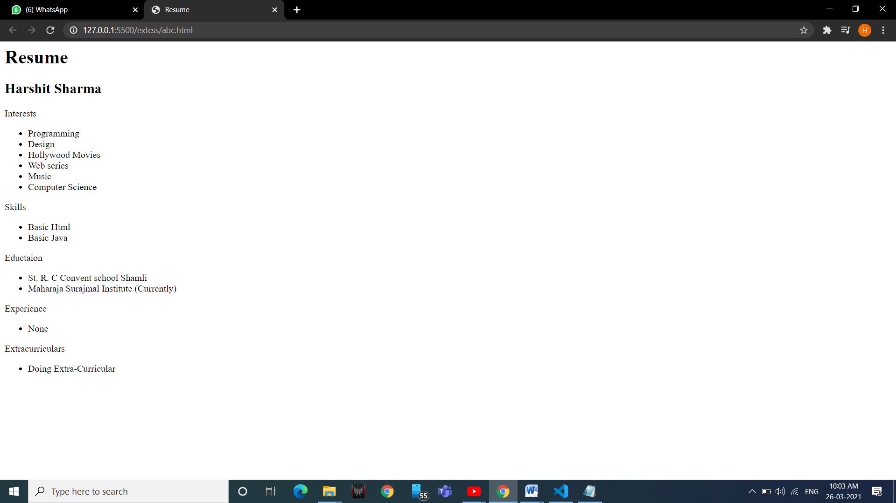

1. **Create a web page with following specifications:**
2. **an ordered list containing name of your friends.**
3. **an unordered list specifying hobbies.**
4. **some links to various search engines.**
5. **links to five different web pages, created by you, opening in new window.**
6. **a link at the top of page so that when clicked jump all way to the bottom of page.**
7. **a link at the bottom of page so that when clicked jump all way to the top of page.**

<!DOCTYPE html>

<html lang="en">

<head>

<title>Document</title>

</head>

<body>

<a id= "top" href="#bottom">To bottom</a>

first to do in file

<h1>ordered list of names of friends </h1>

<ol>

<li>abhishek</li>

<li>avinash</li>

<li>bhagya</li>

<li>sneha</li>

<li>surbhi</li>

<li>etc...</li>

</ol>

<br>

<br>

<br>

<br>

<h1>unordered list specifing hobies</h1>

<ul>

<li>singing</li>

<li>reading</li>

<li>programming</li>

<li>etc...</li>

</ul>

<br>

<br>

<br>

<br>

<a href="https://www.google.com/" target="_blank">Google</a><br>

<a href="https://in.yahoo.com/" target="_blank">yahoo</a><br>

<a href="https://www.bing.com/" target="_blank">bing</a><br>

<br>

<br>

<br>

<a href="extpages/page1.html">page1</a><br>

<a href="extpages/page2.html">page2</a><br>

<a href="extpages/page3.html">page3</a><br>

<a href="extpages/page4.html">page4</a><br>

<a href="extpages/page5.html">page5</a><br>

<br>

<br>

<br>

<br>

<a id="bottom" href="#top">To top</a>

</body>

</html>

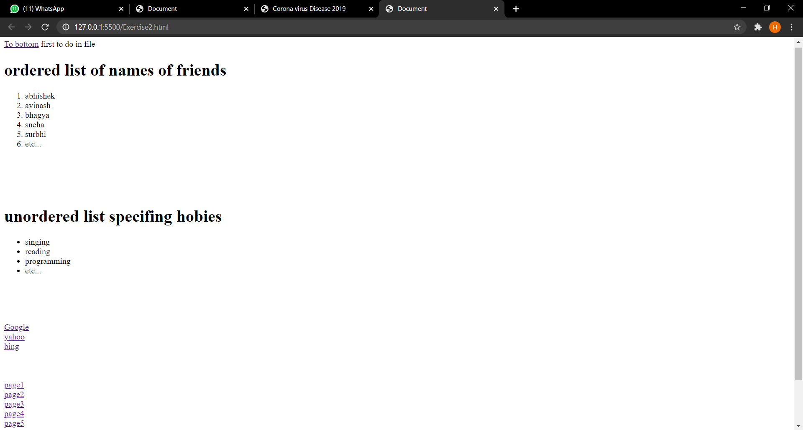

1. **Create the following unordered/ordered nested list as shown in figure.**

<!DOCTYPE html>

<html lang="en">

<head>

<title>Document</title>

</head>

<body>

<h1>Learing Web Development</h1>

<ol type="I">

<li>backgroung skills</li>

<ol type="A">

<li>Unix command</li>

<li>Vim text editor</li>

</ol>

<li>html</li>

<ol type="A">

<li>minimal page</li>

<li>heading</li>

<li>tags</li>

<li>list</li>

<ol type="i">

<li>unordered</li>

<li>ordered</li>

<li>defination</li>

<li>nested</li>

</ol>

<li>links</li>

<ol type="i">

<li>absolute</li>

<li>relative</li>

</ol>

<li>images</li>

</ol>

<li> CSS</li>

<ol type="A">

<li>Anatomy</li>

<li>BAsic Selector</li>

<ol type="i">

<li>Elements</li>

<li>Class</li>

<li>id</li>

<li>Group</li>

</ol>

<li>The Dom</li>

<li>Advanced Selector</li>

<li>Box Model</li>

</ol>

</ol>

</body>

</html>

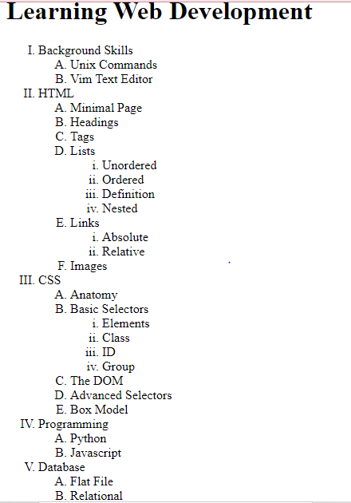

1. **Create the Time-table of your class using HTML tags.**

<!DOCTYPE html>

<html lang="en">

<head>

<title>Document</title>

</head>

<body>

<h1>Creating A Table</h1>

<table width=100% border="10px" cellpadding="20px" cellspacing="30">

<caption>this is a table</caption>

<tr bgcolor="red">

<th>Period</th>

<th>Class</th>

<th>Teacher</th>

</tr>

<tr >

<td align="center">1</td>

<td align="center" >WT</td>

<td align="center">Menal mam</td>

</tr>

<tr>

<td align="center">1</td>

<td align="center">java</td>

<td align="center">Kanika mam</td>

</tr>

<tr>

<td align="center">3</td>

<td align="center">SE</td>

<td align="center">Tarunim Mam</td>

</tr>

</table>

</body>

</html>

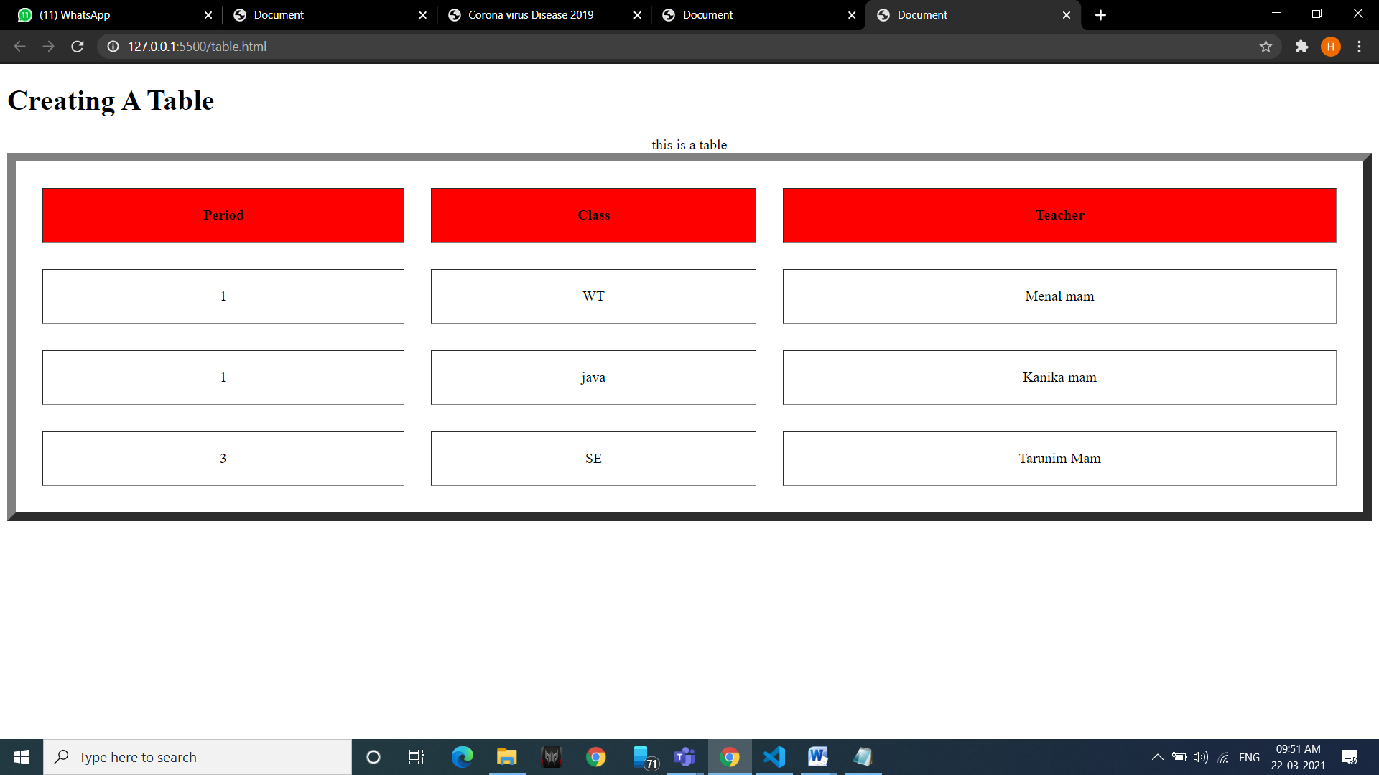5. **Create the following table as shown using HTML.**

<!DOCTYPE html>

<html lang="en">

<head>

<title>Document</title>

</head>

<body>

<table border="10px">

<tr>

<td> <img src=" Vodafone.jpg " ></td>

<td> <img src="bsnl.jpg "></td>

<td> <img src="jio.jpg "></td>

<td> <img src="docomo.jpg "></td>

</tr>

<tr>

<td><img src="airtel.jpg "></td>

<td align="center" colspan="2">List With Images</td>

<td><img src="uninor.jpg " ></td>

</tr>

<tr>

<td><img src="aircel.jpg"></td>

<td><img src="MtS.jpg "></td>

<td><img src="hutch.jpg "></td>

<td> <img src="idea.jpg "></td>

</tr>

</table>

</body>

</html>

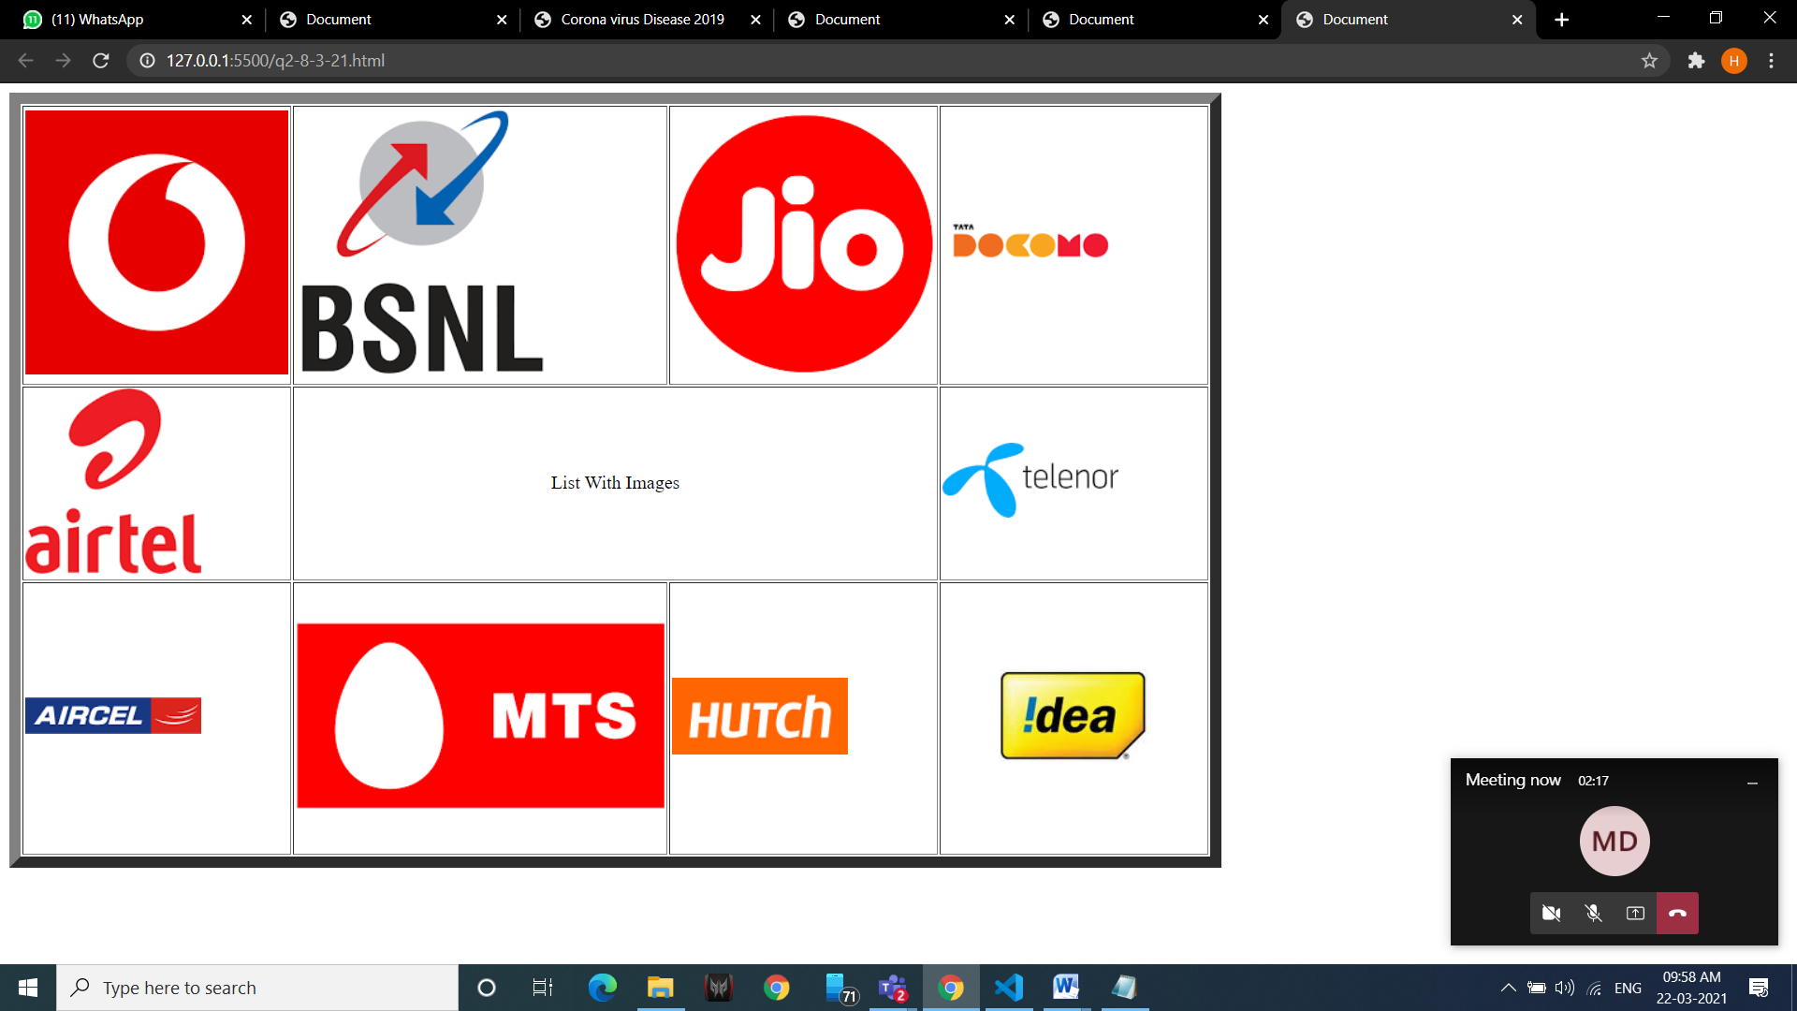

**6. Create a web page using 3 frames and link them to an image, audio and video as shown in figure.**

<!DOCTYPE html>

<head>

<title>Frameset-3</title>

</head>

<frameset rows="20%,50%">

<frame name="hadder" src="audio.html" >

<frameset cols="30%, 70%">

<frame name="second" src="msi.html">

<frame name="third" src="video.html">

</frameset>

</frameset>

</html>

OUTPUT-

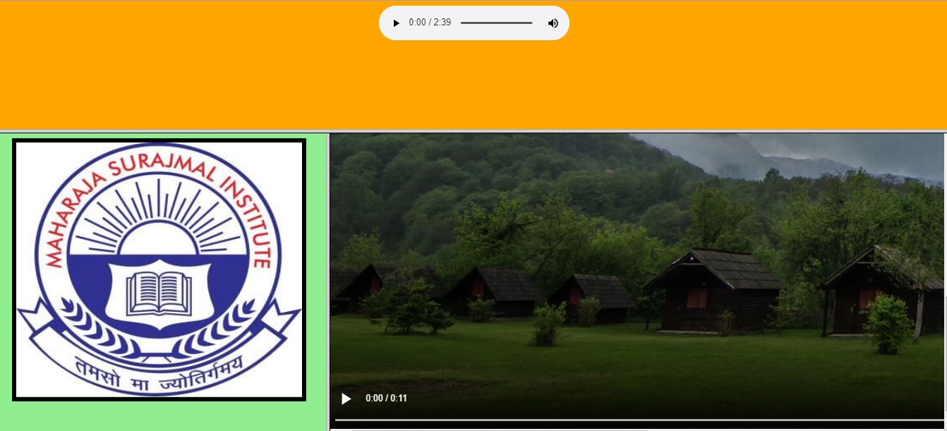

**7. Create a web page having 6 frames and link each frame with 5 different web pages.**

<!DOCTYPE html>

<html lang="en">

<head>

<title>Document</title>

</head>

<frameset rows="25,50,25">

<frame name="top" src="extpages/red.html"></frame>

<frameset cols="50,50">

<frame name="MiddleLeft" src="extpages/green.html"></frame>

<frameset rows="50,50">

<frame name="MiddletopRight" src="extpages/orange.html"></frame>

<frame name="MiddleBtmRight" src="extpages/blue.html"></frame>

</frameset>

</frameset>

<frameset cols="50,50">

<frame name="btmleft" src="extpages/red.html"></frame>

<frame name="btmright" src="extpages/green.html"></frame>

</frameset>

</frameset>

</html>

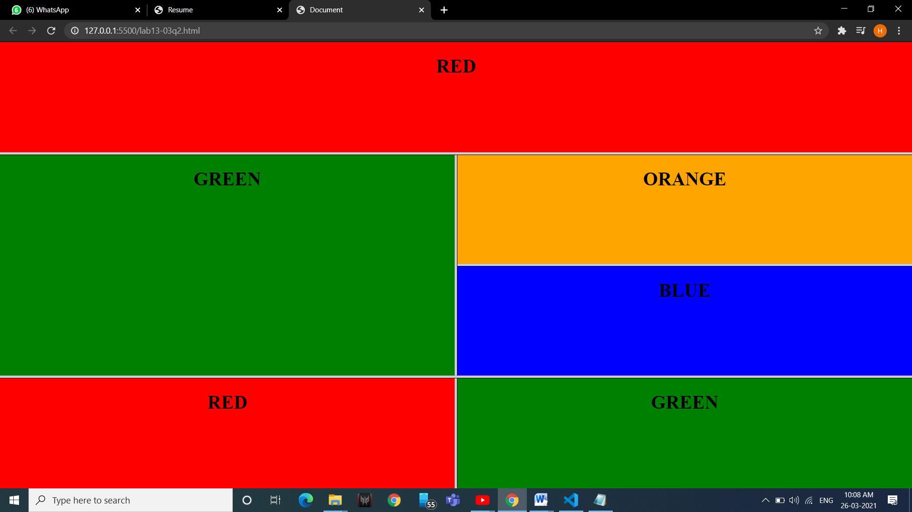

**8. Create the following frameset as shown in figure.**

<!DOCTYPE html>

<html lang="en">

<head>

<title>Document</title>

</head>

<frameset rows="20,70,10" border="2px">

<frame name="top.html" src="extpages/15top.html"> </frame>

<frameset cols="20,80">

<frame name="midleft" src="extpages/15midleft.html"></frame>

<frame name="midright" src="extpages/1ap.html" ></frame>

</frameset>

<frame name="btm" src="extpages/1btm.html"></frame>

</frameset>

</html>

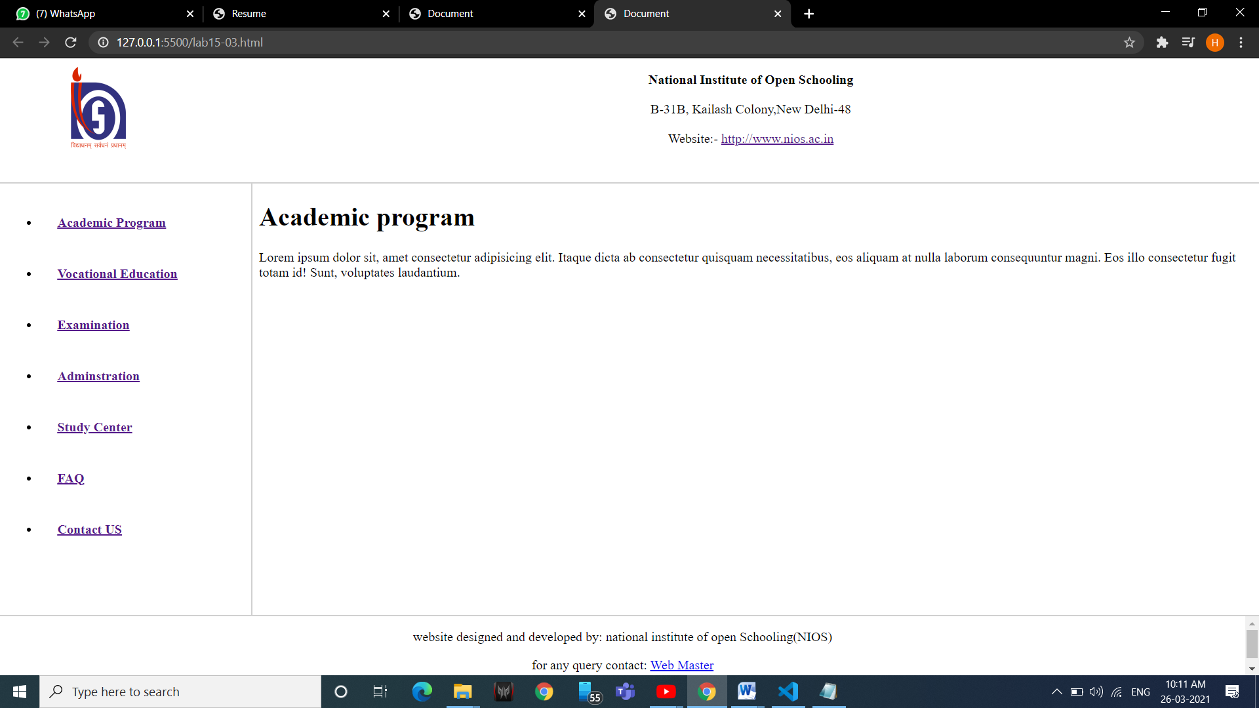

**9. Create the following form in HTML as shown in figure.**

<!DOCTYPE html>

<html lang="en">

<head>

<title>Document</title>

</head>

<body>

<h1 align="center">Computer Socity Of India</h1>

<h2 align="center"> Annual Convention 2021 </h2>

<h3 align="center"> Participation Registration form</h3><br>

<table border="5px" align="center" cellpadding="5px">

<form align="center">

<tr>

<td> <label for="name"> Name of participant : </label> </td>

<td> <input type="text" name="Name" id="Name"></td>

</tr>

<tr>

<th colspan="2" align="center"><label for="address" > Address: </label></th>

</tr>

<tr>

<td><label for="address">Street: </label></td>

<td><input type="text" name="street" id="street"></td>

</tr>

<tr>

<td><label for="Town"> Town: </label></td>

<td><input type="text" name="town" id="town"></td>

</tr>

<tr>

<td><label for="state"> State: </label></td>

<td><input type="text" name="State" id="State"></td>

</tr>

<tr>

<td><label for="Pincode"> Pincode: </label></td>

<td><input type="number" name="Pincode" id="Pincode"></td>

</tr>

<tr>

<td><label for="work"> Select The Work You Are Involved</label> </td>

<td><select name="work" id="work">

<option value="sel">Select</option>

<option value="Ce">Computer Education</option>

<option value="mk">Marketing</option>

<option value="ss">Sales</option>

<option value="Tech">technologies</option>

</select></td>

</tr>

<tr>

<th colspan="2" align="center">

<label for="tut"> Select Any Tutorials You wish to attend : </label>

</th>

</tr>

<tr>

<td> <label for="tut"> On 17 march 2021</label></td>

<td> <select name="tut" id="wtut">

<option value="sel">Select</option>

<option value="Ce">E-commerce</option>

<option value="mk">Digital Marketing</option>

<option value="ss">Email marketing</option>

<option value="Tech">Web technologies</option>

<option value="Tech">Android Development</option>

<option value="Tech">Database Management</option>

</select></td>

</tr>

<tr>

<td><label for="tut"> On 18 march 2021</label></td>

<td><select name="tut" id="wtut">

<option value="sel">Select</option>

<option value="Ce">E-commerce</option>

<option value="mk">Digital Marketing</option>

<option value="ss">Email marketing</option>

<option value="Tech">Web technologies</option>

<option value="Tech">Android Development</option>

<option value="Tech">Database Management</option>

</select></td>

</tr>

<tr>

<td colspan="2"><label for="remark"> any of your Special Requirements in the box</label></td>

</tr>

<tr rowspan="3">

<td colspan="2">

<textarea name="remark" id="rk" cols="55" rows="5"></textarea>

</td>

</tr>

<tr>

<td align="center"><button>Start Over</button></td>

<td align="center"><button>Send Please.!</button></td>

</tr>

</form>

</table>

</body>

</html>

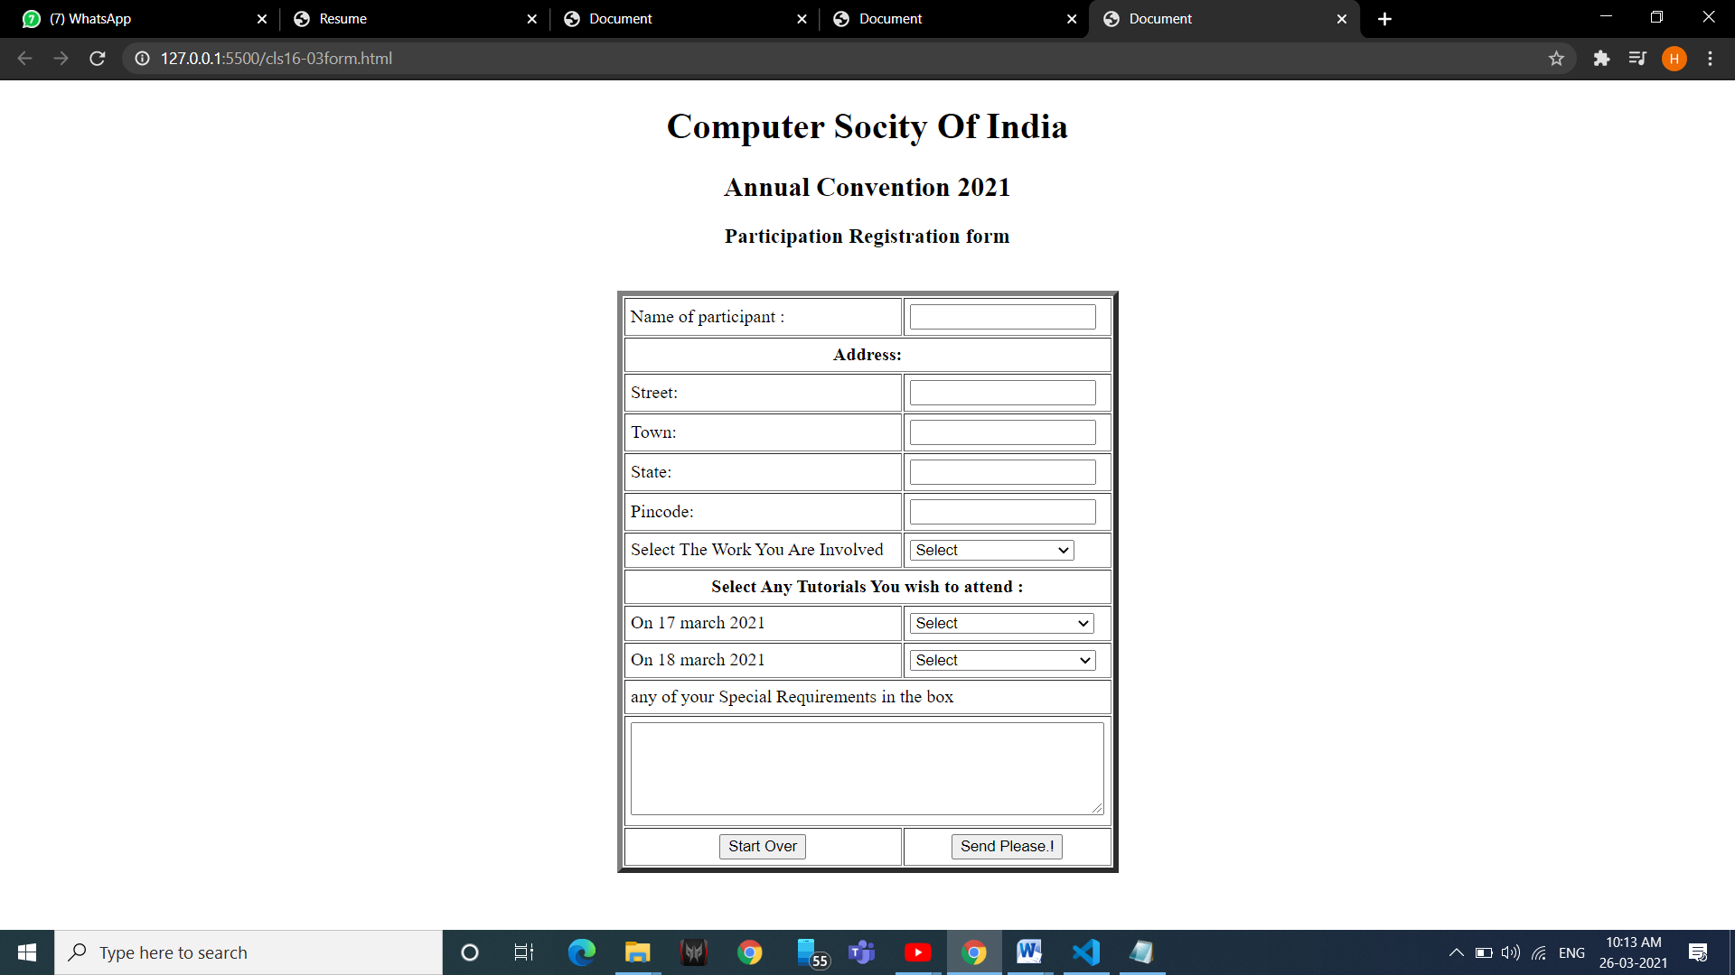

**10. Create an online application form having following specifications:**

1. **position applied for(autofocus), name, nationality, gender, date of birth (selected from auto picked of a text area), address, telephone number and email(required), password(required).**
2. **Educational history, qualifications and skills(checkbox).**
3. **Work experience/employment/training in terms of employer history and number of years of experience selected from a slider. Set max. years of experience to 10 years.**
4. **personal statement.**
5. **two referees including names, occupation, relationship, address, telephone.**
6. **a submit and clear button.**

<html>

<head>

<title>Application Form</title>

</head>

<body>

<center>

<h1>Application Form</h1>

<form>

<label>Position applied for: </label>

<input type="text" name="pos" autofocus><br>

<label>Name: </label>

<input type="text" name="name"><br>

<label>Nationality: </label>

<input type="text" name="nationality"><br>

<label>Gender: </label>

<input type="radio" value="Male" name="gender"> Male

<input type="radio" value="Female" name="gender"> Female

<input type="radio" value="Other" name="gender"> Other<br>

<label>Date of Birth: </label>

<input type="date" name="dob" value = "2000-01-01"><br>

<label>Address: </label><br>

<textarea cols="80" rows="5" value="address">

</textarea><br>

<label>Telephone Number*: </label>

<input type="tel" name="tel" pattern = [0-9]{10} required><br>

<label>Email: </label>

<input type="text" name="mail" required><br>

<label>Password: </label>

<input type="password" name="passwd" required><br>

<label>Educational History: </label><br>

<label>Qualifications:</label><br>

<input type="checkbox" name="q1" value="Pre-Matric">

<label> Pre-Matric</label><br>

<input type="checkbox" name="q2" value="Post-Matric">

<label> Post-Matric</label><br>

<input type="checkbox" name="q3" value="Undergraduate">

<label> Undergraduate</label><br>

<input type="checkbox" name="q4" value="Postgraduate">

<label> Postgraduate</label><br>

<label>Skills:</label><br>

<input type="checkbox" name="s1" value="Communication">

<label> Blogging</label><br>

<input type="checkbox" name="s2" value="Typing">

<label> Communication</label><br>

<input type="checkbox" name="s3" value="Data Entry">

<label> Designing</label><br>

<input type="checkbox" name="s4" value="Coding">

<label> Programming</label><br>

<label>Last company you worked for: </label>

<input type="text" name="Organization" size="40"><br>

<label>Years of Experience: </label><br>

<input type="range" min="1" max="10" value="5"><br>

<pre>1 5 10</pre>

<br>

<input type = "submit"/>

<input type = "reset"/>

</form>

</center>

</body>

</html>

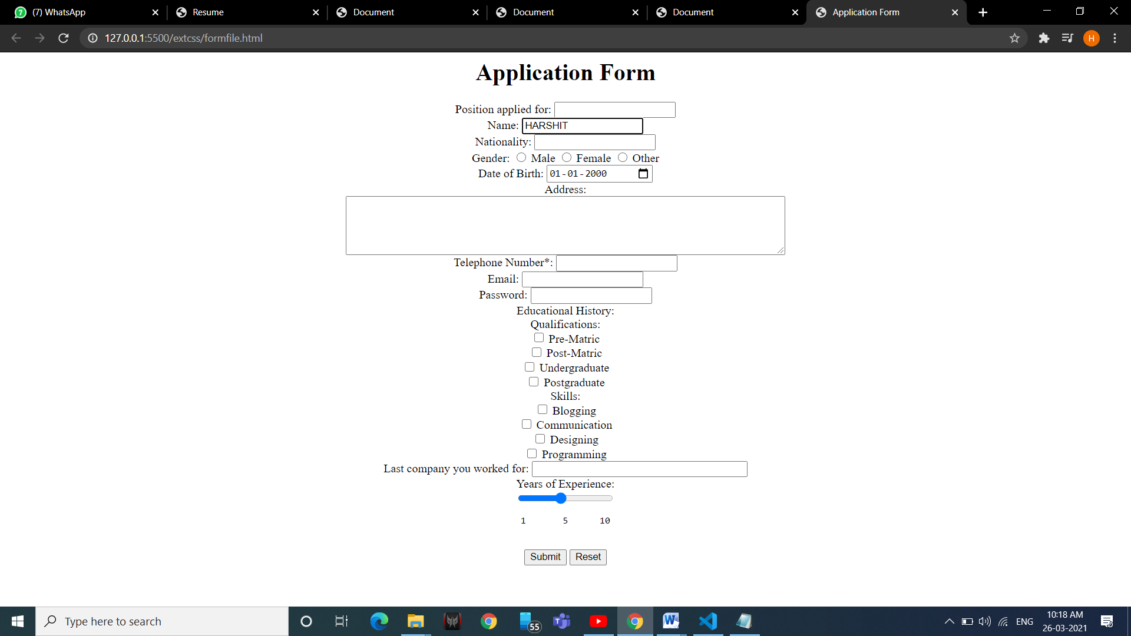

**11. Create an Iframe and write some lines before and after it.**

<!DOCTYPE html>

<html lang="en">

<head>

<title>Document</title>

</head>

<body>

<iframe src="msi.html" frameborder="5px" width="100%" height="175"></iframe>

<table width=100% border="10px">

<tr>

<td> <img src="https://i2.wp.com/msi-ggsip.org/wp-content/uploads/2014/06/Main-Gate.jpg?fit=750%2C500&ssl=1"></img></td>

<td> <iframe src="list.html" frameborder="0" height="500px" width="720" ></iframe></td>

</tr>

</table>

</body>

</html>

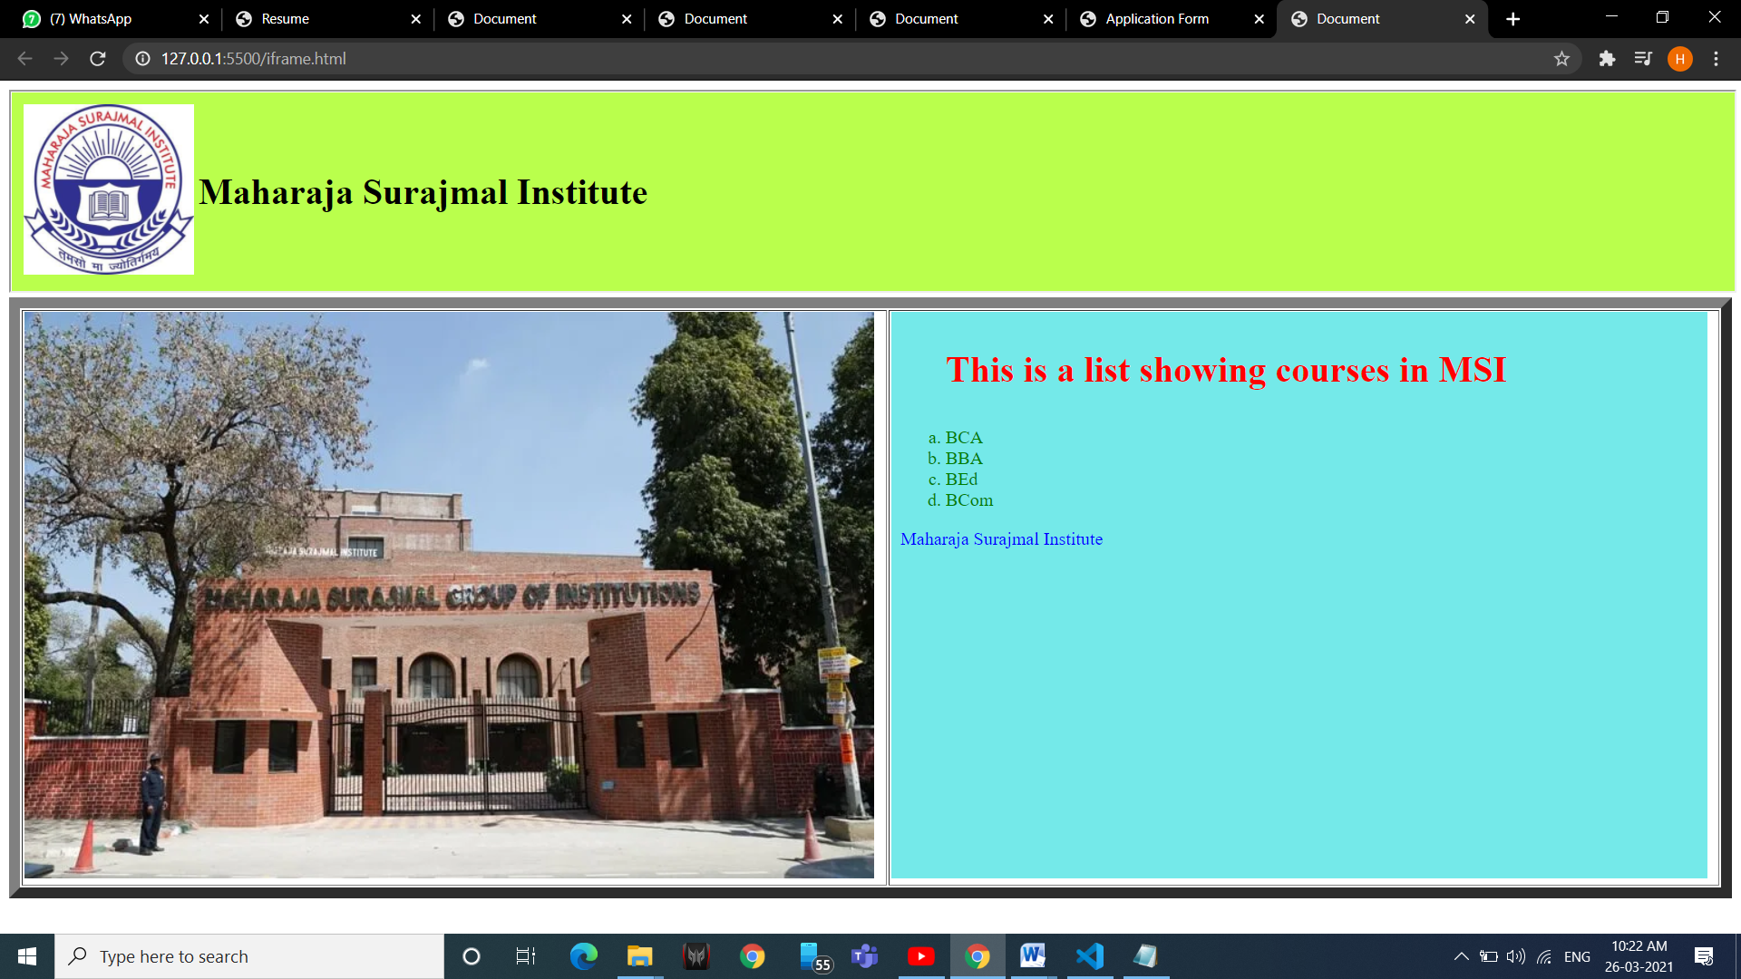

**12- Create a web page showing India’s map and create hotspots on five different states and link them to the e-government sites of the respective states.**

<!DOCTYPE html>

<html lang="en">

<head>

<title>Document</title>

</head>

<frameset cols=40,60>

<frame src="india.html"></frame>

<frame src="" name ="content"></frame>

</frameset>

</html>

**Code of india.html**

<!DOCTYPE html>

<html lang="en">

<head>

<title>Document</title>

</head>

<body>

<img src="cities.png" usemap="#city">

<map name="city">

<area shape="circle" coords="192,172,10" href="delhi.html" target="content">

<area shape="circle" coords="80,289,10" href="ahmedabad.html" target="content">

<area shape="circle" coords="98,378,10" href="mumbai.html" target="content">

<area shape="circle" coords="219,421,10" href="hydrabad.html" target="content">

<area shape="circle" coords="173,520,10" href="bangalore.html" target="content">

<area shape="circle" coords="225,519,10" href="chennai.html" target="content">

<area shape="circle" coords="161,599,10" href="trivandram.html" target="content">

<area shape="circle" coords="342,353,10" href="orrisa.html" target="content">

</map>

</body>

</html>

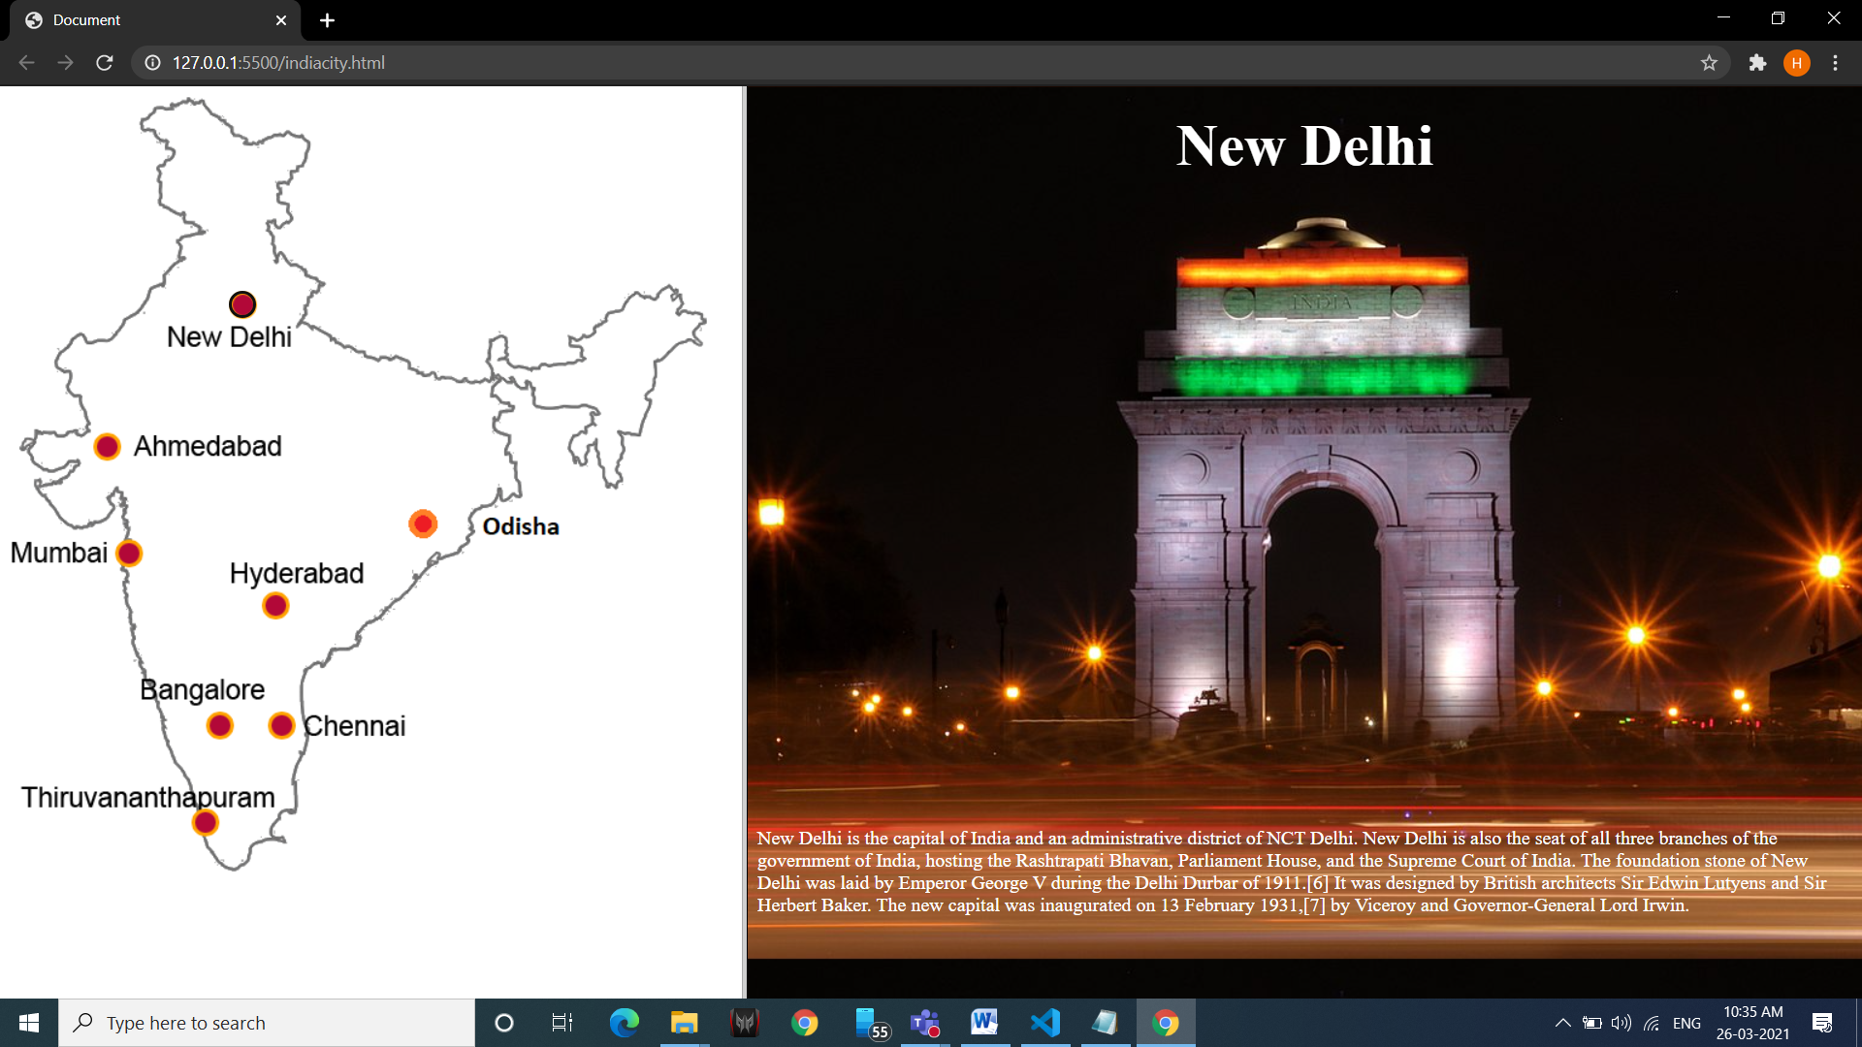

**13.Create the following page using CSS as shown in figure.**

<!DOCTYPE html>

<html lang="en">

<head>

<title>Document</title>

<style>

body {

background-color: gray;

margin: 0px;

padding: 0px;

}

#top {

margin-top: 40px;

}

.left {

display: inline-block;

padding: 5px;

width: 100px;

border: 2px;

background-color: white;

margin-right: 40px;

margin-top: 5px;

margin-left: 25px;

}

div{

display: inline-block;

}

#right{

margin-top: 0px;

padding: 0px;

margin-left: 150px;

}

h1{

font-size: 50px;

}

p{

font-size: 25px;

}

address{

margin-top: 50px;

}

</style>

</head>

<body>

<div>

<div id="top" class="left">Homepage</div><br>

<div class="left">Musings</div><br>

<div class="left">My Town</div><br>

<div class="left">Links</div><br>

</div>

<div id="right">

<h1> My First Styled Page</h1>

<p> Welcome to my first styled page!</p>

<p> it LAcks images and everythig but have links that dont go anywhere</p>

<address> made by <br> myself </address>

</div>

</body>

</html>

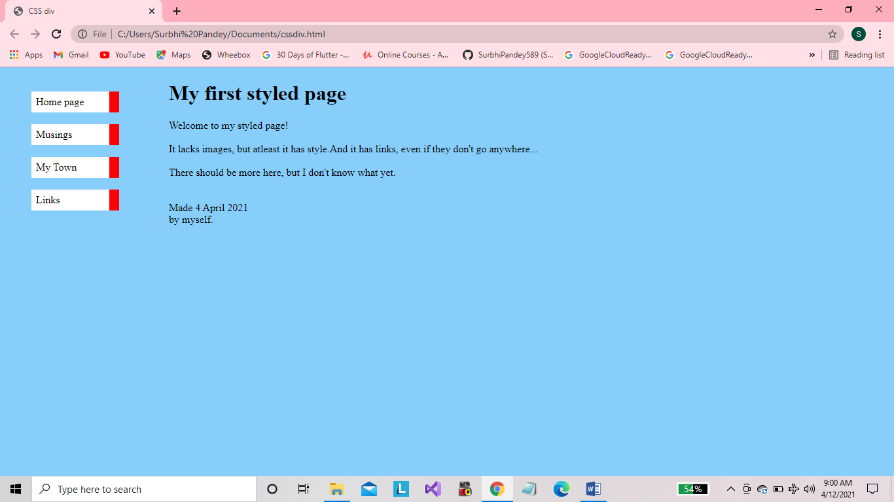

**14. Create a CSS Zebra Striping a table.**

<!DOCTYPE html>

<html lang="en">

<head>

<title>Document</title>

</head>

<style>

table{

margin-top: 150px;

}

#heading{

background-color: azure;

}

.black{

background-color: gray;

}

td{

align-items: center;

}

</style>

<body>

<table border="5px" align="center">

<tr id="heading">

<th>id</th>

<th colspan="5">Name</th>

<th colspan="3">Major</th>

</tr>

<tr class="black">

<td>1001</td>

<td colspan="5">Gopl Murthy</td>

<td colspan="3">physics</td>

</tr>

<tr >

<td>1002</td>

<td colspan="5">joe sen</td>

<td colspan="3">economics</td>

</tr>

<tr class="black">

<td>1003</td>

<td colspan="5">Chandu Yadav</td>

<td colspan="3">Chemistry</td>

</tr>

<tr >

<td>1004</td>

<td colspan="5">Shalini Gupta</td>

<td colspan="3">Zoology</td>

</tr>

<tr class="black">

<td>105</td>

<td colspan="5">Vivek Kumar</td>

<td colspan="3">maths</td>

</tr>

<tr >

<td>1006</td>

<td colspan="5">Sameer ali</td>

<td colspan="3">Botany</td>

</tr>

</table>

</body>

</html>

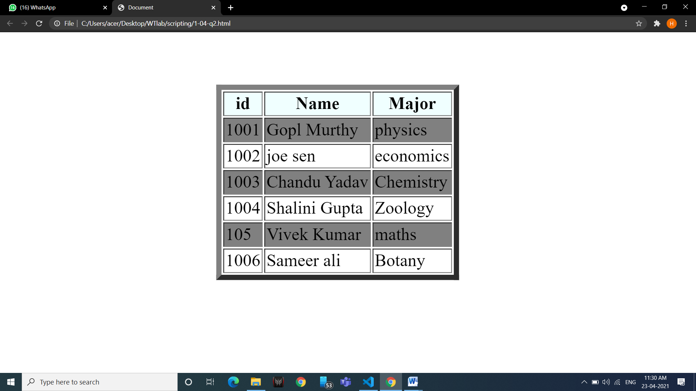

**15. Create a CSS based button.**

<!DOCTYPE html>

<html lang="en">

<head>

<title>Document</title>

<style>

#btn{

color: White;

background-color: red;

height: 100px;

width: 250px;

border-radius: 5px;

}

</style>

</head>

<body>

<button id="btn"> Button </button>

</body>

</html>

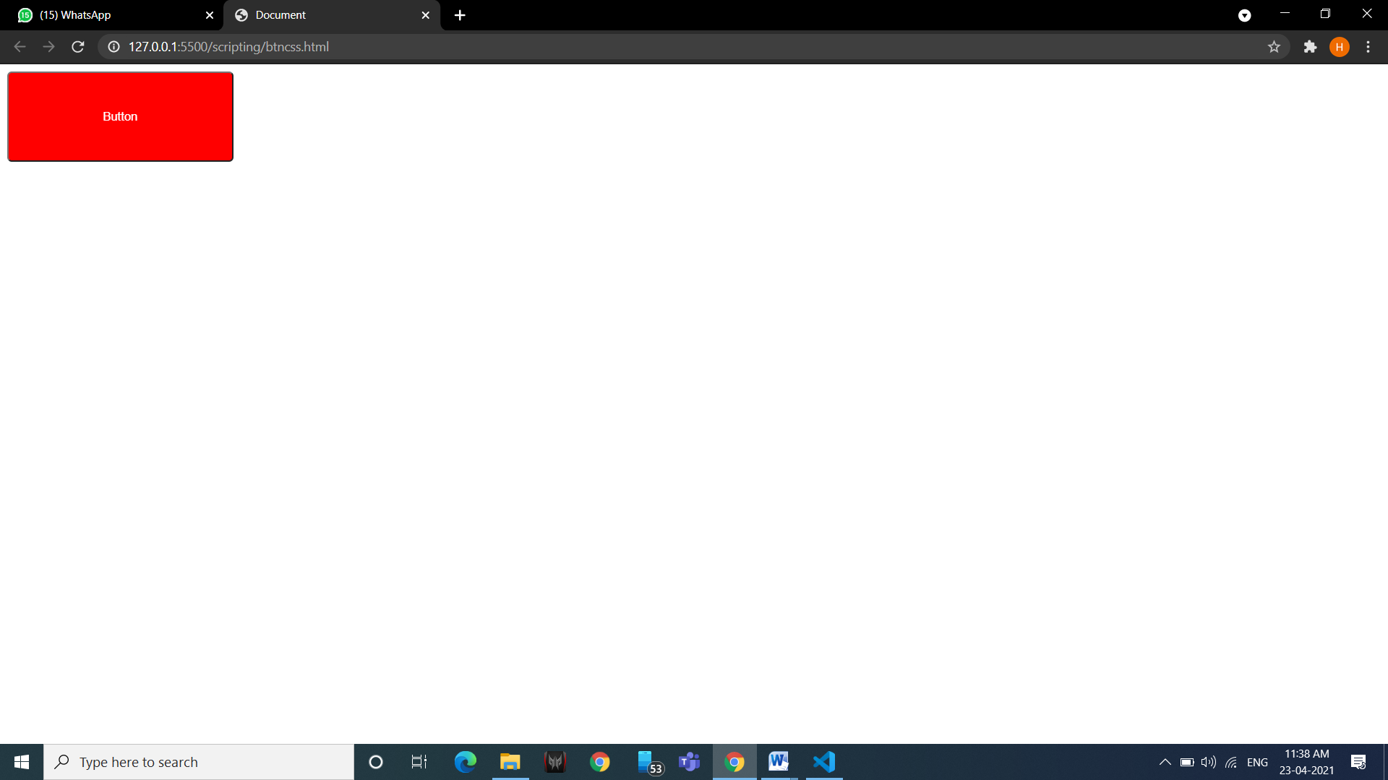

**16. Use two images and using CSS transition properties on hover change one to another.**

<!doctype html>

<head>

<title>CSS Image Transition</title>

<style>

#img1{

width:400px;

height:300px;

border:5px solid yellow; transition-duration:2s;

transition-timing-function:ease;

transition-delay:1s;

}

#img1:hover{

content:url("html.png");

width:500px;

}

</style>

</head>

<body>

<img src="Java.png " id="img1">

</body>

</html>

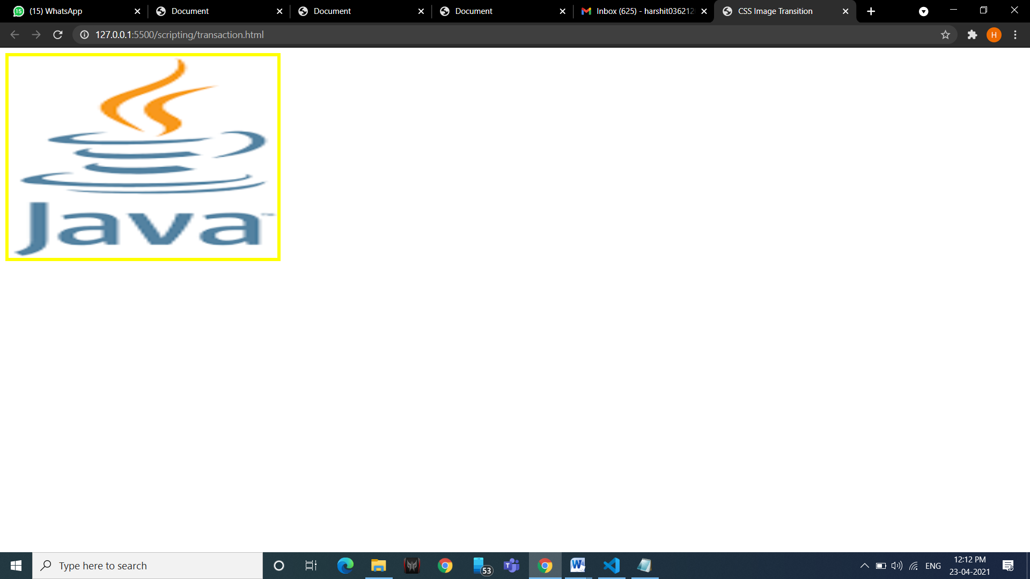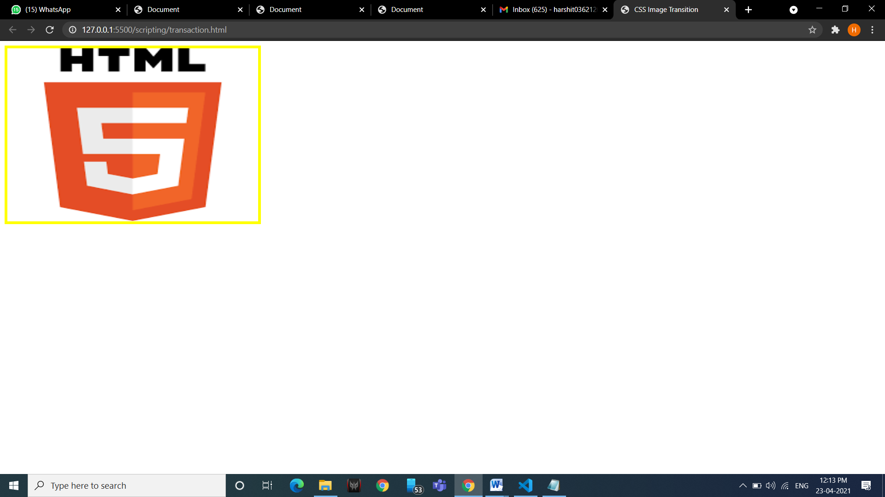

**17. Write about incredible India using external stylesheet.**

<!doctype html>

<html>

<head>

<title>CSS ExternalSS</title>

<link rel="stylesheet" href="csssheet.css">

</head>

<body>

<h1><u><b>Incredible India</b></u></h1>

<p>one of the oldest civilisations in the world. India is a mosaic of multicultural experiences. With a rich heritage and myriad attractions, The country is among the most popular tourist destinations in the world. It covers an area of 32,87,263 sq. km. Extending from the snow-covered Himalayan heights to the tropical rain forests of the south. As the 7th largest country in the world, India stands apart from the restof Asia, Marked off as it is by mountains and the sea which give the the country a distinct geographical entity.</p>

<h2><u><b>Popular in India</b></u></h2>

<p>India is a home to the finest architectural heritage, serene ghats, spectacular landscapes and largest tiger reserve.</p>

<a>Beaches</a> &nbsp&nbsp&nbsp&nbsp <a>Statue Of Unity</a> &nbsp&nbsp&nbsp&nbsp <a>The land of Gandhi</a> &nbsp&nbsp&nbsp&nbsp <a>Cathedrals and Basilicas</a> &nbsp&nbsp&nbsp&nbsp <a>Forts and Palaces</a>

<h2><u><b>Must Visit Destinations</b></u></h2>

<p>From historical cities to natural splendours, come see the best of India.</p>

<ul type="none">

<li><a>Dalhouise</li></a> &nbsp&nbsp <li><a>Darjeeling</a></li> &nbsp&nbsp <li><a>Gangtok</a></li> &nbsp&nbsp

<li><a>Ratnagiri</a></li> &nbsp&nbsp <li><a>Ooty</a></li> &nbsp&nbsp <li><a>Srinagar</a></li> &nbsp&nbsp

<li><a>Statute of Unity</a></li> &nbsp&nbsp <li><a>Kasauli</a></li> &nbsp&nbsp <li><a>Mathura-Vrindavan</a></li><br>

<li><a>Leh-Ladakh</a></li> &nbsp&nbsp <li><a>Shillong</a></li> &nbsp&nbsp <li><a>Mahabaleshwar</a></li>

</ul>

</body>

</html>

**CSS-**

body{

text-align:center; background-color:grey; text-color:black;

}

p{

font-family:constantia; font-size:20px;

}

h1{

font-family:algerian; font-size:30px; color:maroon;

}

h2{

font-family:times new roman; font-size:30px; color:maroon;

}

li > a{

width:15%; background-color:white; border:3px solid yellow; display:inline-block;

}

a{

decoration:none; color:black; font-family:constantia; font-size:20px;

}

a:hover{

width:15%; color:black; background-color:lemongreen;

}

**18. Write a program demonstrating all operators of JS.**

<!doctype html>

<html>

<head>

<title>JS Operator</title>

<style>

</style>

</head>

<body align="center">

<script>

var x=6, y=120, a=23, b=44, u=16, v=18;

document.write("<b><u>JAVASCRIPT OPERATORS</u></b><br><br>");

document.write("<b>Arithmetic Operators ::</b> given x = 6 and y = 120 <br>");

document.write("Addition = ", x+y, "<br>");

document.write("Subtraction = ", x-y, "<br>");

document.write("Multiplication = ", x*y, "<br>");

document.write("Division = ", x/y, "<br>");

document.write("Modulus = ", x%y, "<br>");

document.write("Increment = ", ++x, "<br>");

document.write("Decrement = ", --x, "<br>");

document.write("Ternary = " , x>y?x:y, "<br>");

document.write("Exponentiation = ", y**x, "<br><br>");

document.write("<b>Relational Operators ::</b> given a=23 and b=44 <br>");

document.write("Equal to :(a==23) = ", (a==23), "<br>");

document.write("Greater than:(a>b) = ", (a>b), "<br>");

document.write("Less than equal to:(a<=b) = ", (a<=b), "<br><br>");

document.write("<b>Logical Operators ::</b> given u=16 and v=18 <br>");

document.write("AND :(u>20 && v<20 ) = ", (u>20 && v<20), "<br>");

document.write("OR:(u>20 || v<20 ) = ", (u>20 || v<20), "<br>");

document.write("NOT:( !(u==v) ) = ", (!(u==v)), "<br><br>");

</script>

</body>

</html>

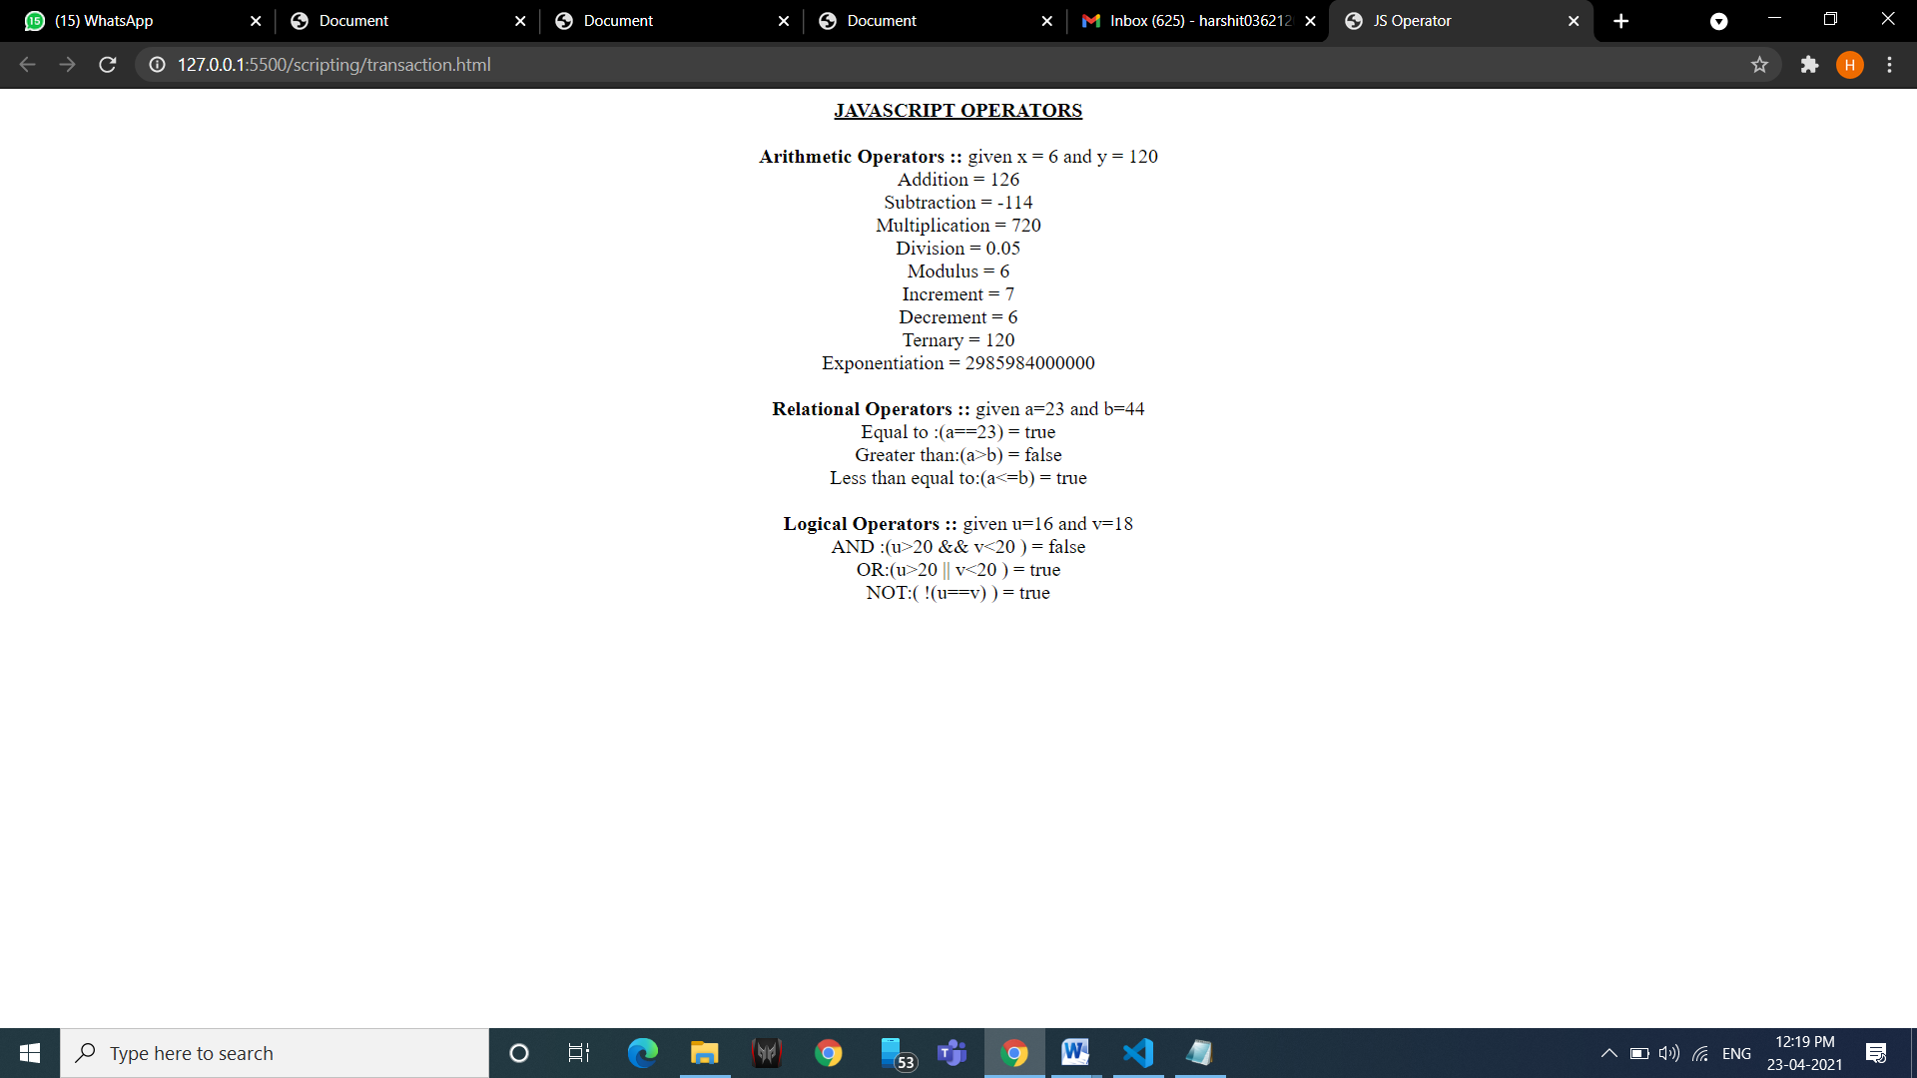

**19. Write a JS program to find:**

1. **factorial of number**

<!-- fact

prime

reverse of a number -->

<!DOCTYPE html>

<html lang="en">

<head>

<title>Document</title>

</head>

<body> <br> <br> <br>

<input type="number" name="inp" id="inp"> <br> <br> <br>

<input type="submit" name="submit" id="submit" onclick="fact()"> <br>

<h3 id="result"></h3>

<script>

function fact()

{

var a= Number(document.getElementById("inp").value);

var result = 1;

for(var i=1 ; i<=a; i++)

{

result= result*i;

}

document.getElementById("result").innerHTML= "Fact of " +a +" is " +result;

}

</script>

</body>

</html>

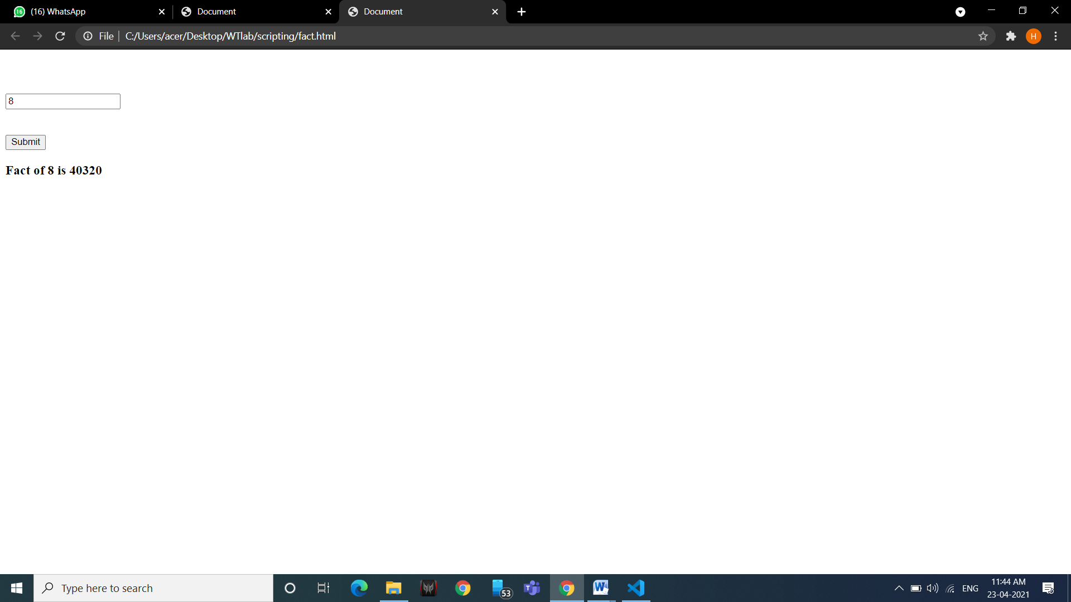

**b. prime numbers in a range**

<!DOCTYPE html>

<html lang="en">

<head>

<title>Document</title>

</head>

<body>

<br> <br> <br>

<input type="number" name="inp" id="inp"> <br> <br> <br>

<input type="submit" name="submit" id="submit" onclick="prime()"> <br>

<h3 id="result"></h3>

<script>

function prime() {

var a = Number(document.getElementById("inp").value);

var flag = 0;

document.getElementById("result").innerHTML= "Prime Numbers Upto " + a + " are = ";

for (var i = 2; i < a; i++) {

for (var j = 2; j < i; j++) {

if (i % j == 0) {

flag++;

}

}

if (flag == 0) {

document.getElementById("result").append(i +", ");

}

flag = 0;

}

}

</script>

</body>

</html>

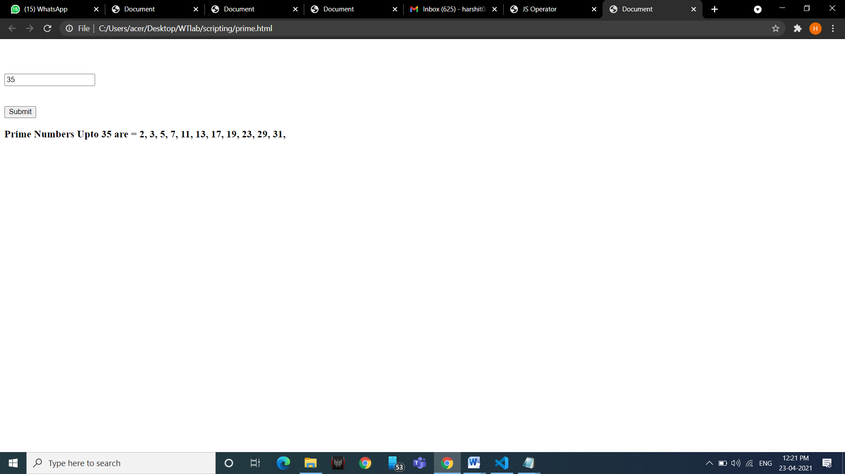

**c. reverse of a number**

<!DOCTYPE html>

<html lang="en">

<head>

<title>Document</title>

</head>

<body> <br> <br> <br>

<input type="number" name="inp" id="inp"> <br> <br> <br>

<input type="submit" name="submit" id="submit" onclick="reverse()"> <br>

<h3 id="result"></h3>

<script>

function reverse() {

var re = 0, num2, temp;

num2 = document.getElementById("inp").value;

temp = num2;

while (num2 != 0) {

re = re * 10;

re = re + num2 % 10;

num2 = num2 - num2 % 10;

num2 = num2 / 10;

}

document.getElementById("result").innerHTML = "Reverse of the number " + temp + " is: " + re;

}

</script>

</body>

</html>

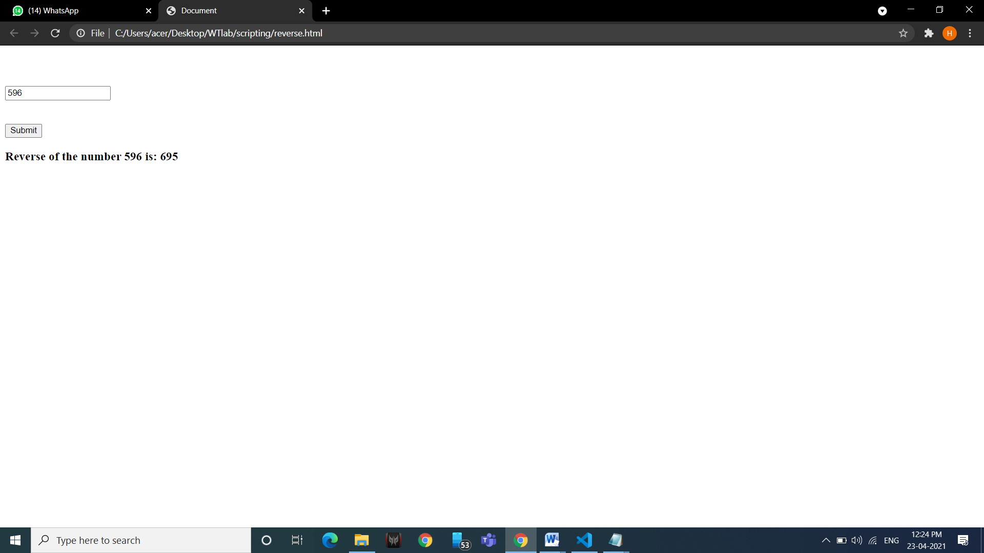

**20. Write a JS program to wish user at different hours of a day.**

<html>

<body>

<script>

var welcome;

var date = new Date();

var hour = date.getHours();

var minute = date.getMinutes();

var second = date.getSeconds();

if (minute < 10) {

minute = "0" + minute;

}

if (second < 10) {

second = "0" + second;

}

if (hour < 12) {

welcome = "good morning";

} else if (hour < 17) {

welcome = "good afternoon";

} else {

welcome = "good evening";

}

document.write("<h2>" + "<font color='red'>" + welcome + "</font>" + " welcome to our website");

document.write("<br>" + hour + ":" + minute + ":" + second);

</script>

</body>

</html>

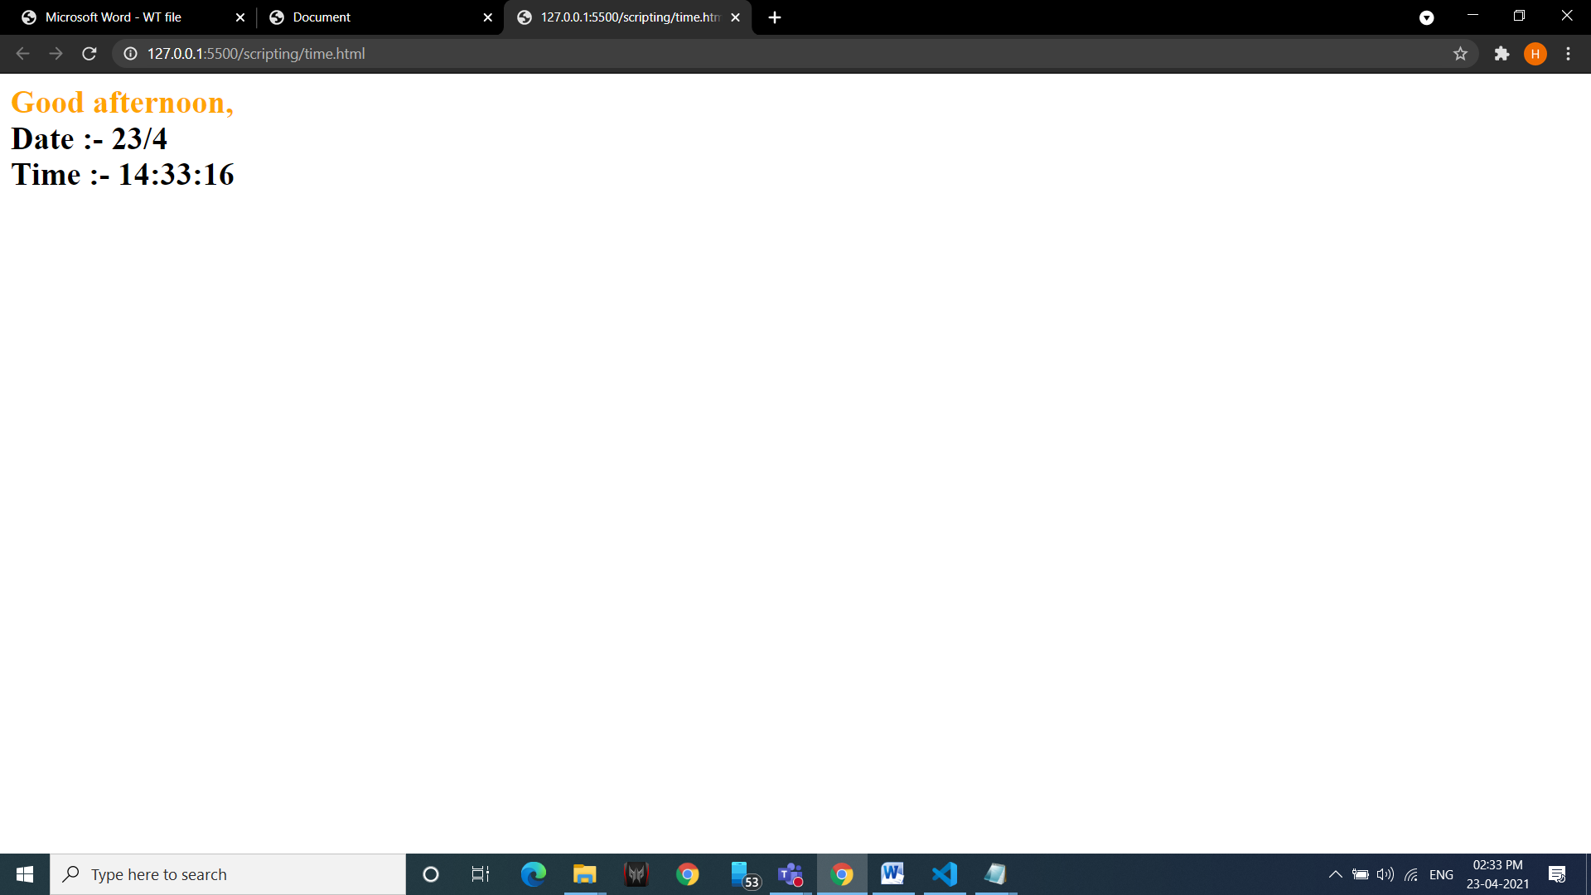

**21. Prompt a user for the cost price and selling price of an article and output the profit and loss percentage.**

<!DOCTYPE html>

<html lang="en">

<head>

<title>Document</title>

</head>

<body>

<div> <p id="p3"></p> </div>

<script>

var cp=window.prompt("Enter cost price : ");

var sp=window.prompt("Enter selling price : ");

if(parseInt(cp) > parseInt(sp)){

document.getElementById("p3").innerHTML="Loss percentage(%) = "+( (parseInt(cp) - parseInt(sp))/parseInt(cp) )*100;

}

else if(parseInt(sp) > parseInt(cp)){

document.getElementById("p3").innerHTML="Profit percentage(%) = "+( (parseInt(sp) - parseInt(cp))/parseInt(cp) )*100;

}

else{

document.getElementById("p3").innerHTML="Neither profit nor loss";

}

</script>

</body>

</html>

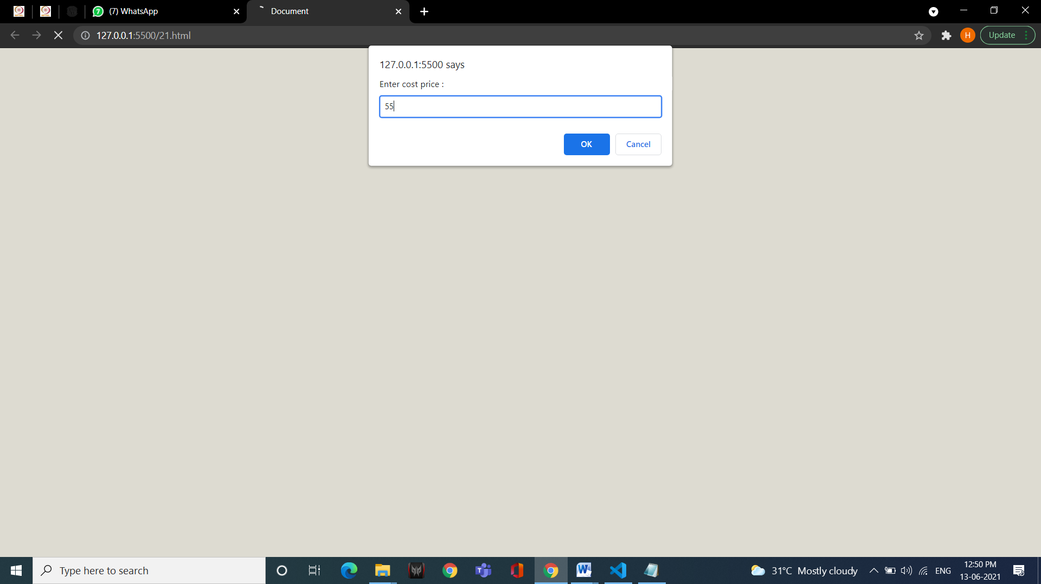

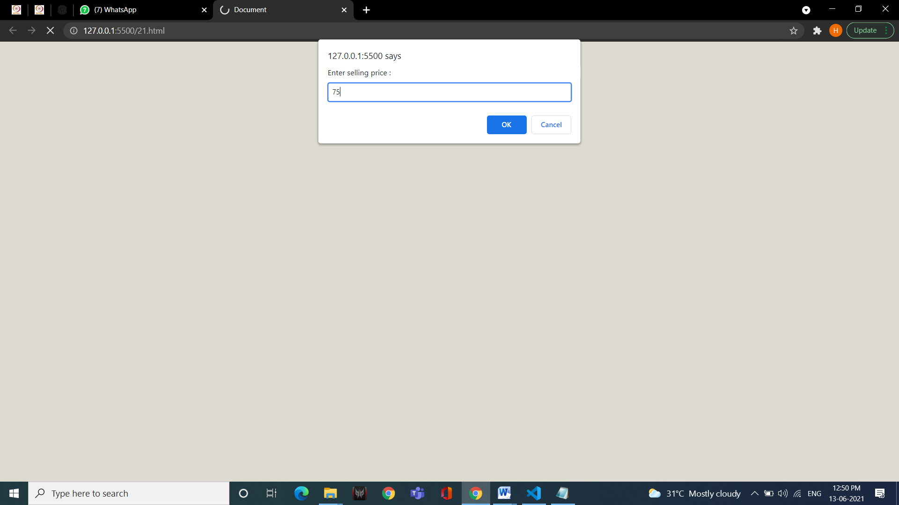

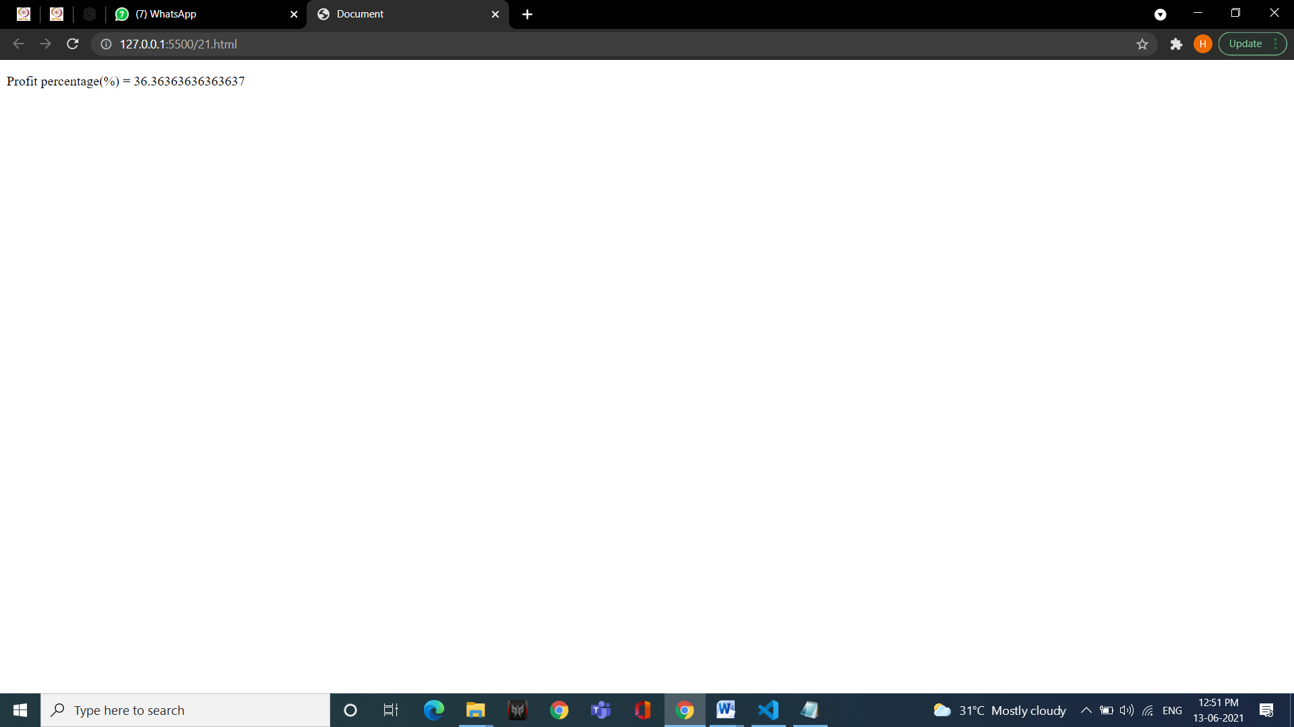

**22. Write a JS program to input a string from the user and abbreviate it.**

<!DOCTYPE html>

<html lang="en">

<head>

<title>Document</title>

</head>

<body>

<input type="text" name="" id="str1">

<h1 id="Stringg"> </h1>

<button onclick="abb()"> Click</button>

<h2 id="result"></h2>

<Script>

function abb() {

var str = document.getElementById("str1").value;

var i ;

var z= str.length;

var str = str.split(" ");

document.getElementById("result").innerHTML= str[0].substr(0,1).toUpperCase() + str[0].substr(1 , str[0].length) + " " + str[1].substr(0,1).toUpperCase() + ".";

}

</Script>

</body>

</html>

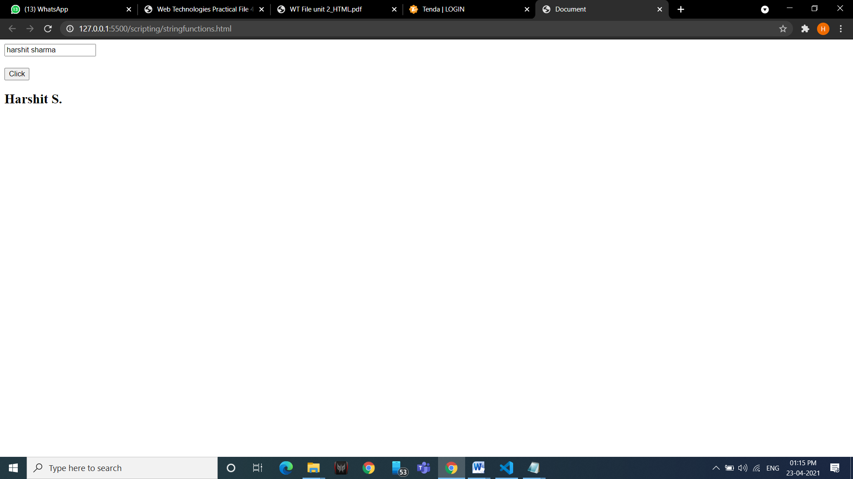

**23. Write a JS program to show mouse event handling.**

<!DOCTYPE html>

<html lang="en">

<head>

<meta charset="UTF-8">

<meta http-equiv="X-UA-Compatible" content="IE=edge">

<meta name="viewport" content="width=device-width, initial-scale=1.0">

<title>Document</title>

</head>

<body>

<button onclick="func1()" > Click Me..!</button>

<script>

function func1(){

document.write(" <h1>Heyy</h1>");

}

</script>

</body>

</html>

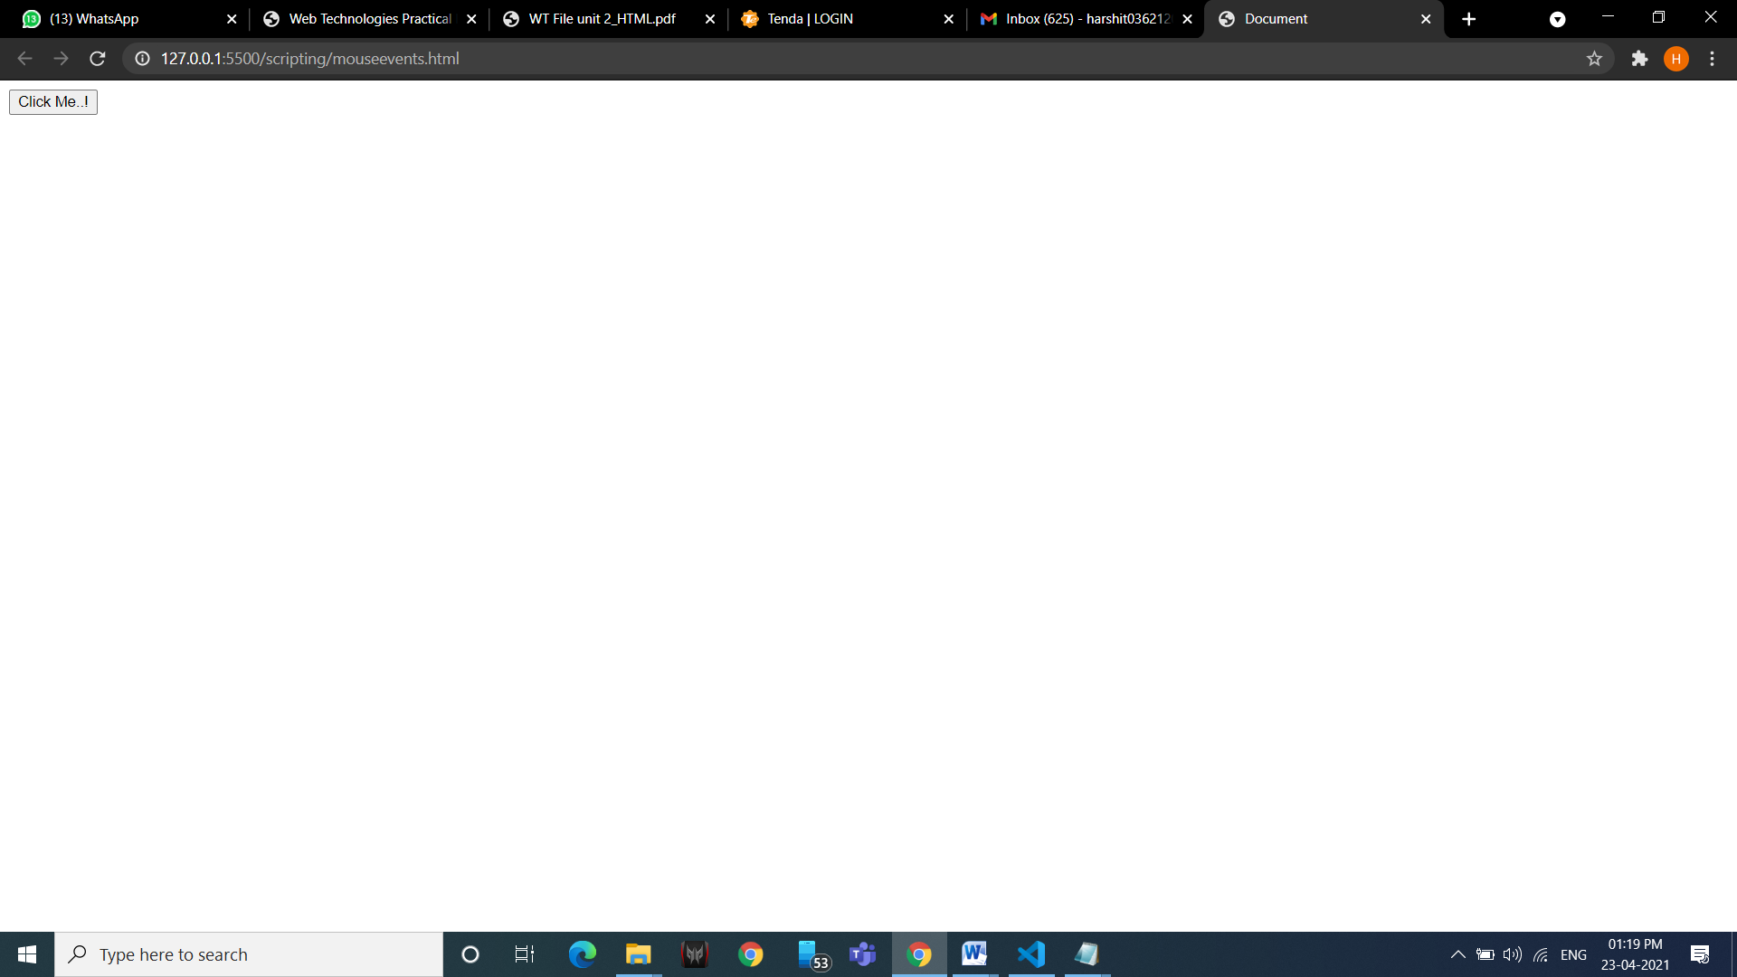

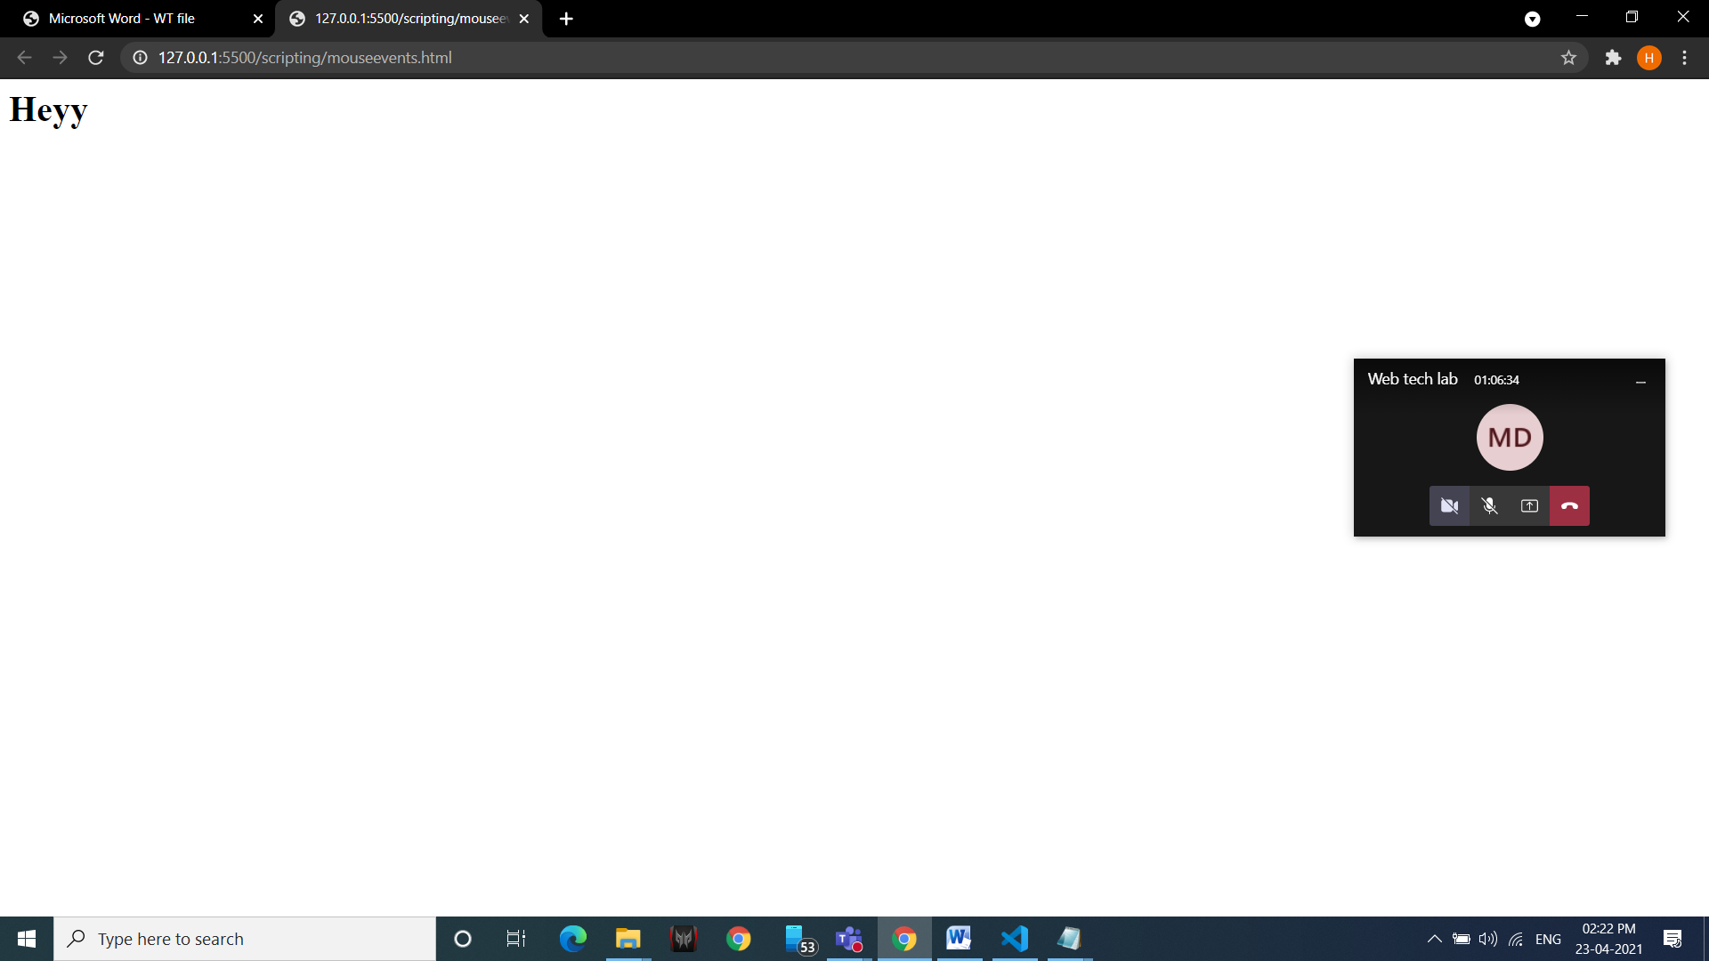

**25. Write a script that takes 2 integers from user and displays sum, average, product, largest and smallest in alert box.**

<!DOCTYPE html>

<html lang="en">

<head>

<title>Document</title>

<style>

button{

width: 100px;

height: 30px;

margin: 10px;

}

p{

size: 25px;

}

</style>

</head>

<body>

<br> <br> <br>

<table border="5px" align="center">

<tr>

<td>First Number</td>

<td>

<input type="number" id="fn">

</td>

</tr>

<tr>

<td>Second Number</td>

<td>

<input type="number" id="sn">

</td>

</tr>

</table>

<br><br>

<div align="center">

<button onclick="myfn(1)">+</button> <br>

<button onclick="myfn(2)">-</button> <br>

<button onclick="myfn(3)">*</button><br>

<button onclick="myfn(4)">%</button> <br>

<button onclick="Max()">Max</button> <br>

</div>

<script lang="javascript" type="text/javascript">

function myfn(str){

var a= document.getElementById("fn").value;

var b=document.getElementById("sn").value;

var result;

switch (str) {

case 1:

result= parseInt(a) + parseInt(b);

break;

case 2:

result= parseInt(a) - parseInt(b);

break;

case 3:

result= parseInt(a) * parseInt(b);

break;

case 4:

result= parseInt(a) % parseInt(b);

break;

default:

break;

}

alert(result);

}

function Max()

{

var a= document.getElementById("fn").value;

var b=document.getElementById("sn").value;

var result;

if(parseInt(a)>parseInt(b))

{

result=a;

}

else if(parseInt(a)<parseInt(b))

{

result=b;

}

else {

result= "equal";

}

alert(result);

}

</script>

</body>

</html>

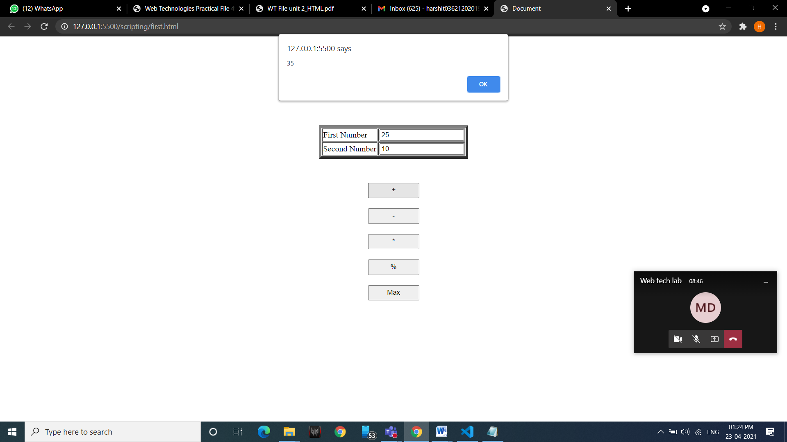

**26. Write a JS program to demonstrate setTimeout function.**

<!DOCTYPE html>

<html lang="en">

<head>

<title>Document</title>

</head>

<body>

<button onclick="func()"> Click..!</button>

<script>

function func()

{

setTimeout(() => {alert("You Clicked")}, 2000);

}

</script>

</body>

</html>

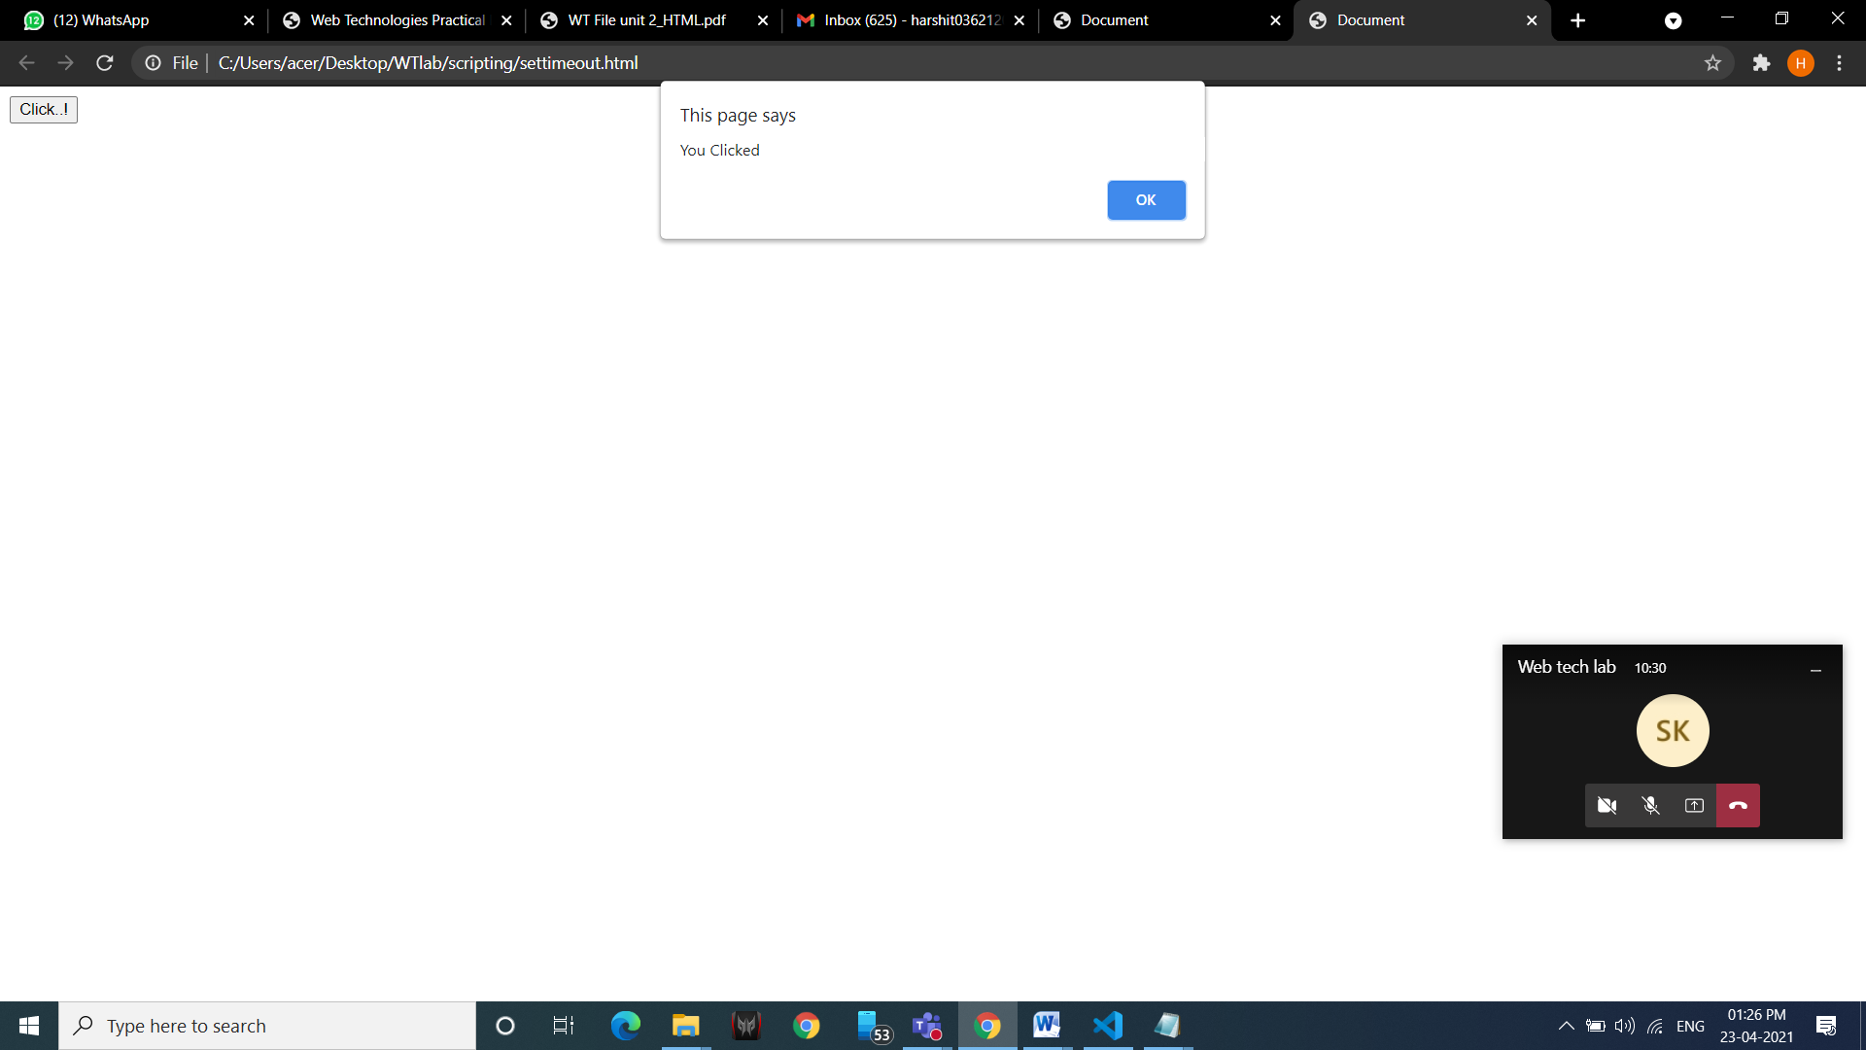

**27. Write a JS program to sort an array.**

<!DOCTYPE html>

<html lang="en">

<head>

<meta charset="UTF-8">

<meta http-equiv="X-UA-Compatible" content="IE=edge">

<meta name="viewport" content="width=device-width, initial-scale=1.0">

<title>Document</title>

</head>

<body>

<h1>Sorting an array</h1>

<h3 id="act"></h3>

<h3 id="actarr"></h3> <br> <br>

<h3 id="aftr"></h3>

<h3 id="result"></h3>

<script>

document.getElementById("act").innerHTML="Before Sort: ";

var arr= [34,12,67,89,32];

document.getElementById("actarr").innerHTML=arr;

document.getElementById("aftr").innerHTML="After sort: ";

var sortedarr = arr.sort();

document.getElementById("result").innerHTML=sortedarr;

</script>

</body>

</html>

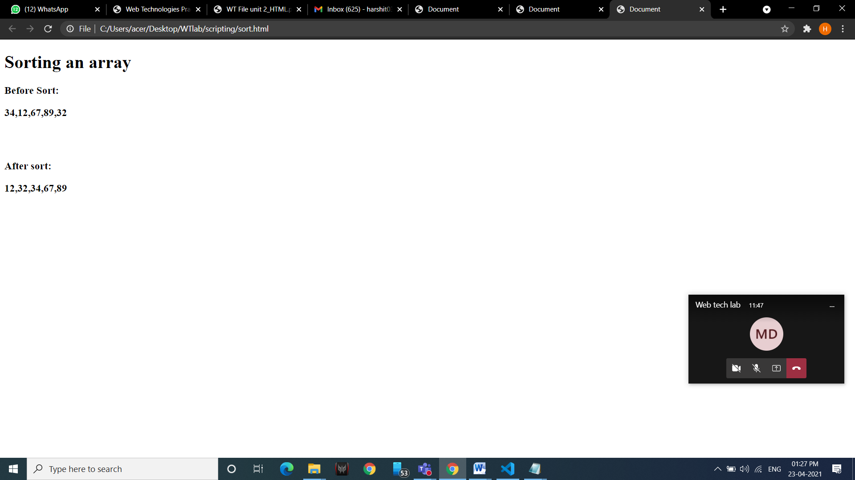

**28 .Write a JS program to capitalize first letter of a string.**

<!DOCTYPE html>

<html lang="en">

<head>

<title>Document</title>

</head>

<body>

<script>

let str = prompt("Enter String");

alert(str[0].toUpperCase() + str.substr(1, str.length));

</script>

</body>

</html>

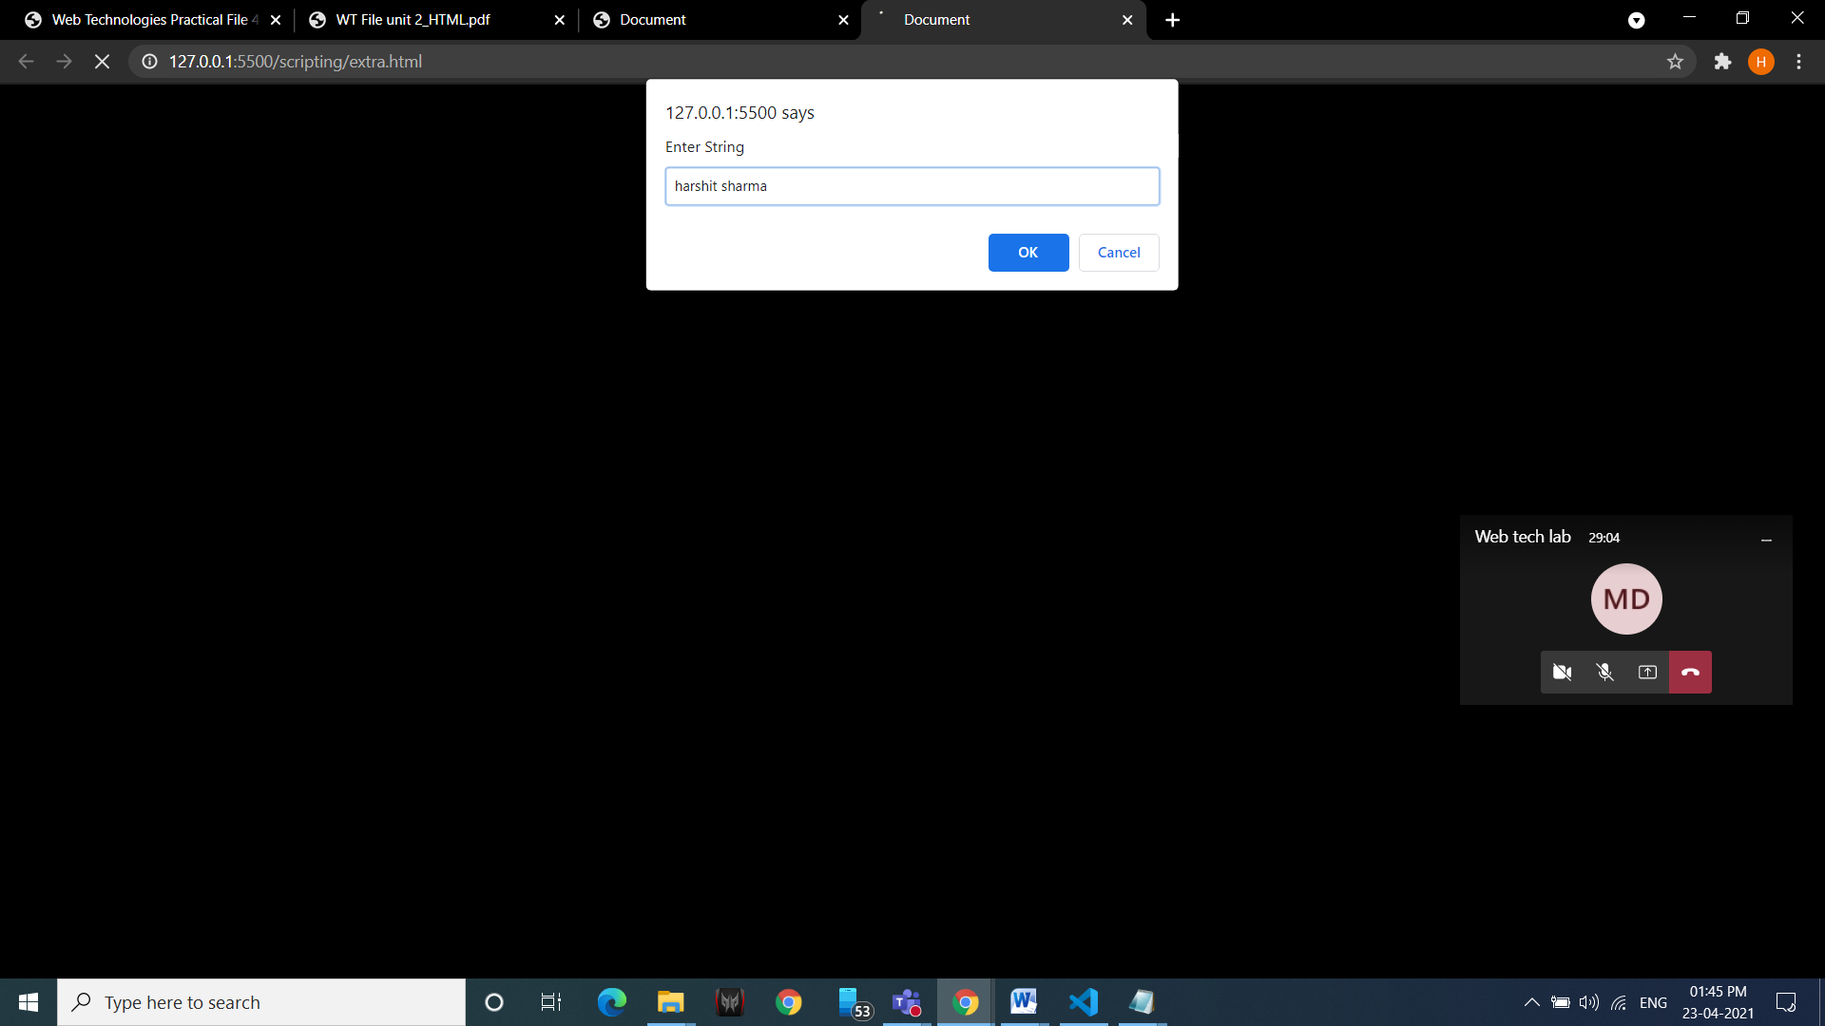

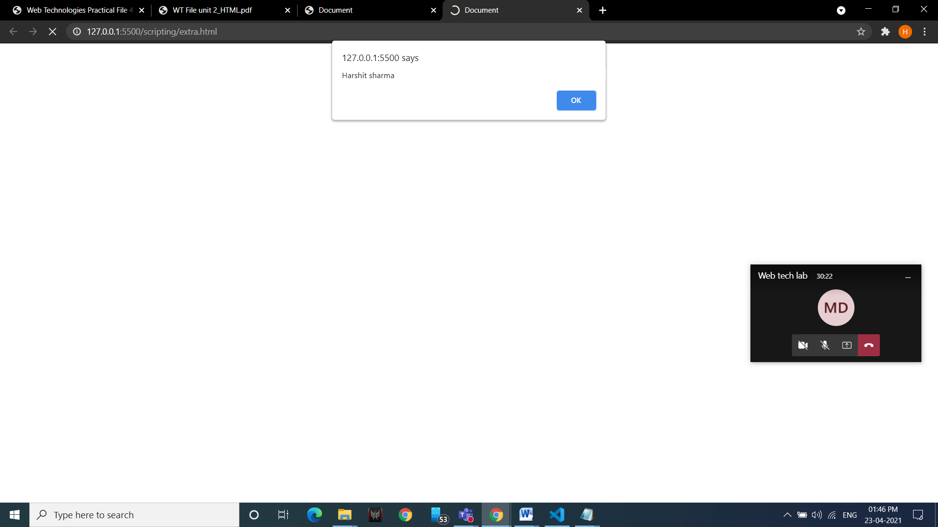

**29. Write a JS program to demonstrate blur, focus and reset event.**

<!DOCTYPE html>

<html>

<body>

Enter your name: <input type="text" id="fname" onblur="myFunction()">

<p>When you leave the input field, a function is triggered which transforms

the input text to upper case.</p>

<script>

function myFunction() {

var x = document.getElementById("fname");

x.value = x.value.toUpperCase();

}

</script>

</body>

</html>

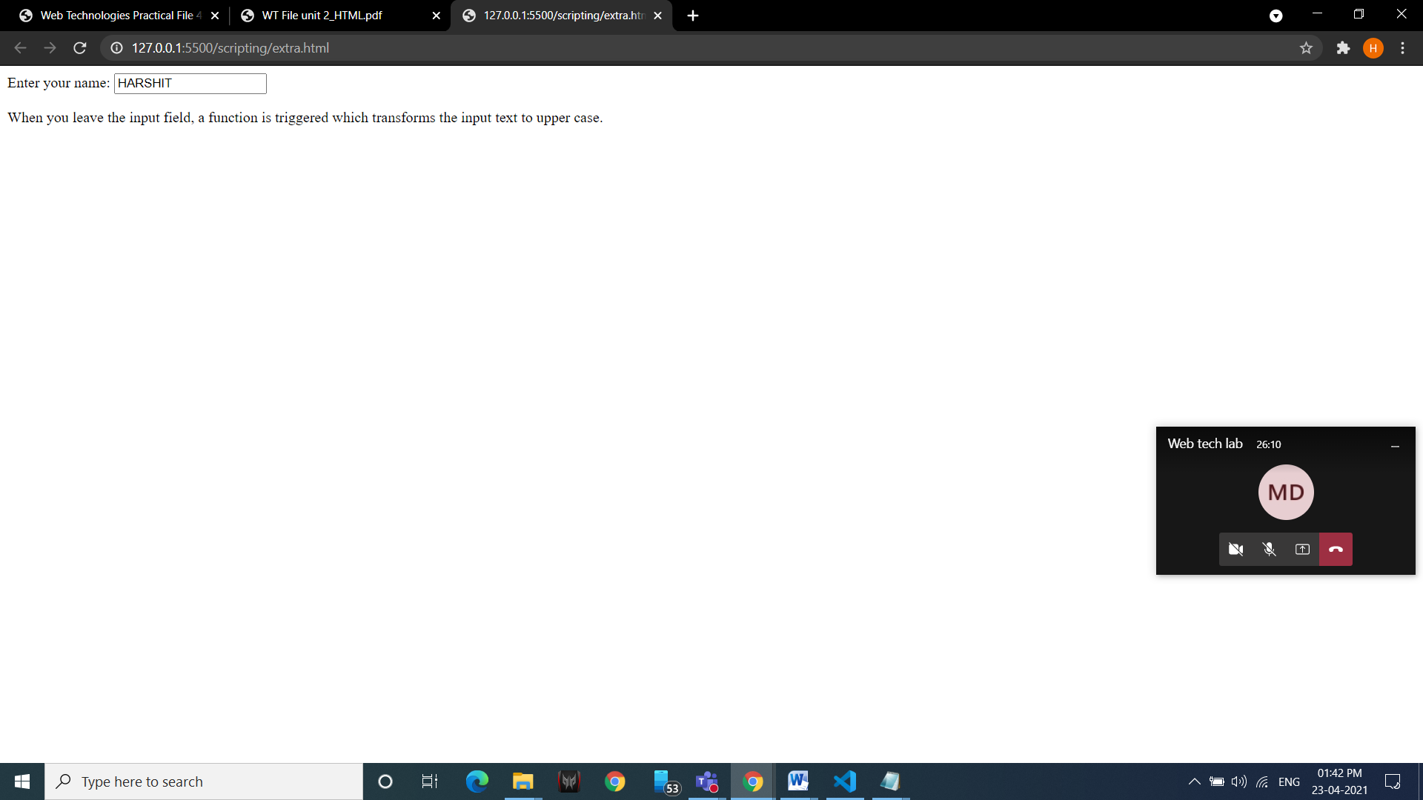

**30. Write an event bubbling program in JavaScript.**

<!DOCTYPE html>

<html lang="en">

<head>

<title>Document</title>

</head>

<body> BODY

<div onmousedown="alert('<div> tag')">DIV

<ul onmousedown="this.style.borderRadius='20px' ">UNORDERED LIST

<p onmousedown="this.style.backgroundColor='aqua' ">PARAGRAPH</p>

</ul>

</div>

</body>

</html>

**31. Write a JS program to prompt the user to enter number and change the style of ordered list using switch statement.**

<!doctype html>

<html>

<head>

<title>window objects</title>

<style>

body{ font-size:30px; }

</style>

</head>

<body>

<script>

var type=window.prompt("Enter your ordered list type: 1(small roman),2(capital alphabet), 3(capital roman)");

document.writeln("<b><u>List is as follows: </u></b>");

switch(parseInt(type)) {

case 1 :

document.writeln(" <ol type='i'><li> Red</li><li> Orange</li><li>Green</li><li> Yellow</li><li> Blue</li></ol> "); break;

case 2 :

document.writeln(" <ol type='A'><li> Red</li><li> Orange</li><li>Green</li><li> Yellow</li><li> Blue</li></ol> "); break;

case 3 :

document.writeln(" <ol type='I'><li> Red</li><li> Orange</li><li>Green</li><li> Yellow</li><li> Blue</li></ol> "); break;

default:

document.writeln("You entered invalid number"); break;

}

</script>

</body>

</html>

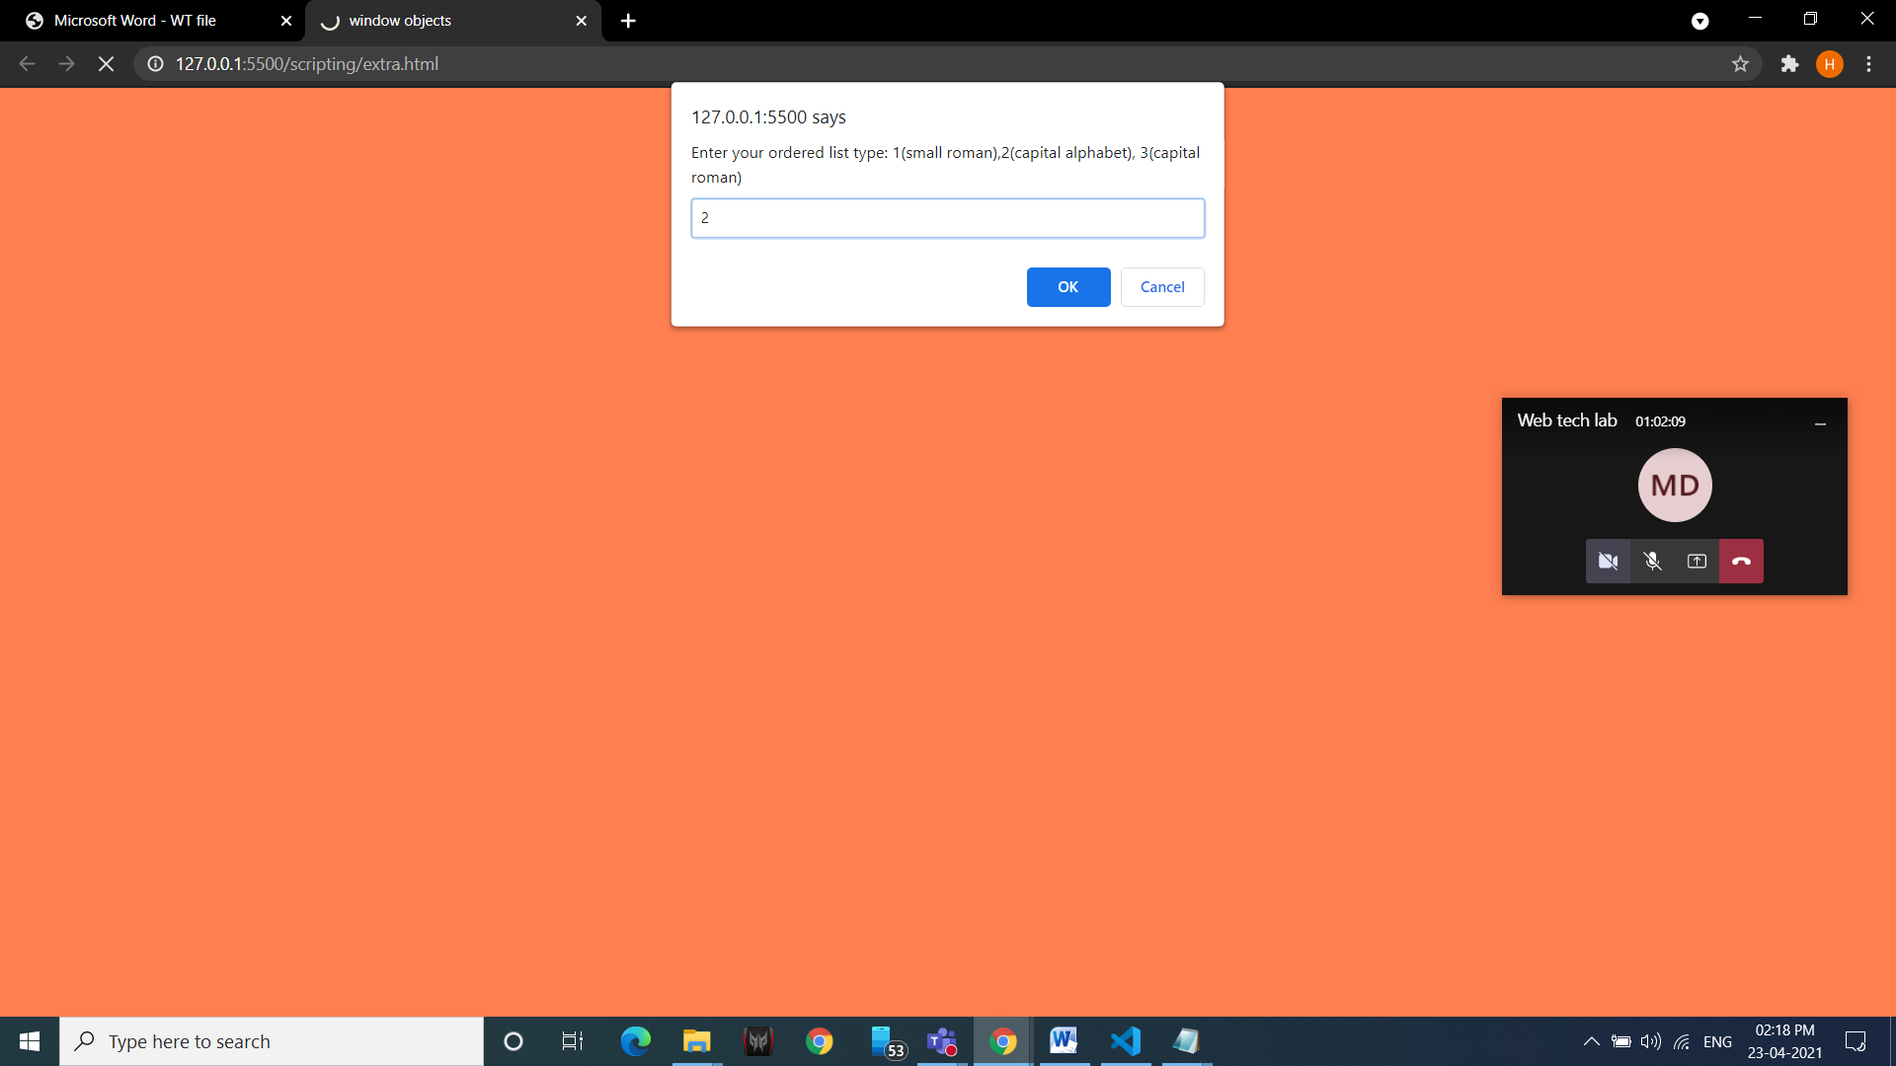

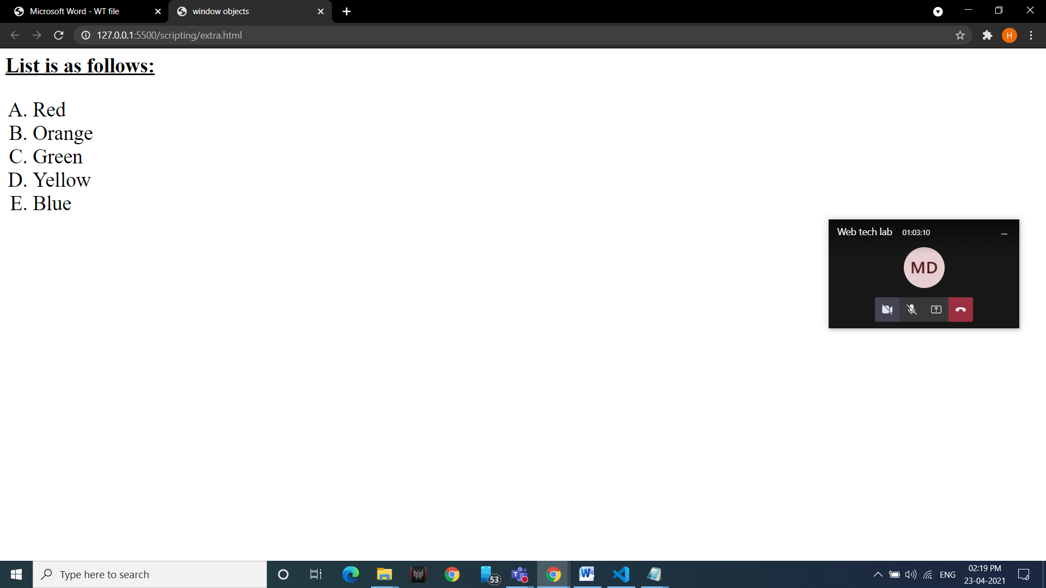

**32. Write a program to demonstrate all the following filters on an image:**

**(a)Blur (b)Brightness (c)Contrast (d)Drop-shadow (e)Grayscale (f)Hue-rotate (g)Invert (h)Opacity (i)Saturate (j)Sepia (k)Flip**

<!doctype html>

<html>

<head>

<title>flip filter</title>

<style>

img {width:300px; height:220px;}

.flip {transform:scaleX(-1);}

.blur {filter:blur(5px);}

.brightness {filter:brightness(0.5);}

.contrast {filter:contrast(200%);}

.drop-shadow {filter:drop-shadow(8px 8px 10px gray);}

.grayscale {filter:grayscale(100%);}

.huerotate {filter:hue-rotate(90deg);}

.invert {filter:invert(100%);}

.opacity {filter:opacity(30%);}

.saturate {filter:saturate(8);}

.sepia {filter:sepia(100%);}

</style>

</head>

<body bgcolor="orange">

a)BLUR: <img class="blur" src="flower.jpg">

b)BRIGHTNESS: <img class="brightness" src="flower.jpg">

c)CONTRAST: <img class="contrast" src="flower.jpg">

d)DROP-SHADOW: <img class="drop-shadow" src="flower.jpg">

e)GRAYSCALE: <img class="grayscale" src="flower.jpg">

f)HUEROTATE: <img class="huerotate" src="flower.jpg">

g)INVERT: <img class="invert" src="flower.jpg">

h)OPACITY: <img class="opacity" src="flower.jpg">

i)SATURATE: <img class="saturate" src="flower.jpg">

j)SEPIA: <img class="sepia" src="flower.jpg">

k)FLIP: <img class="flip" src="flower.jpg">

</body>

</html>

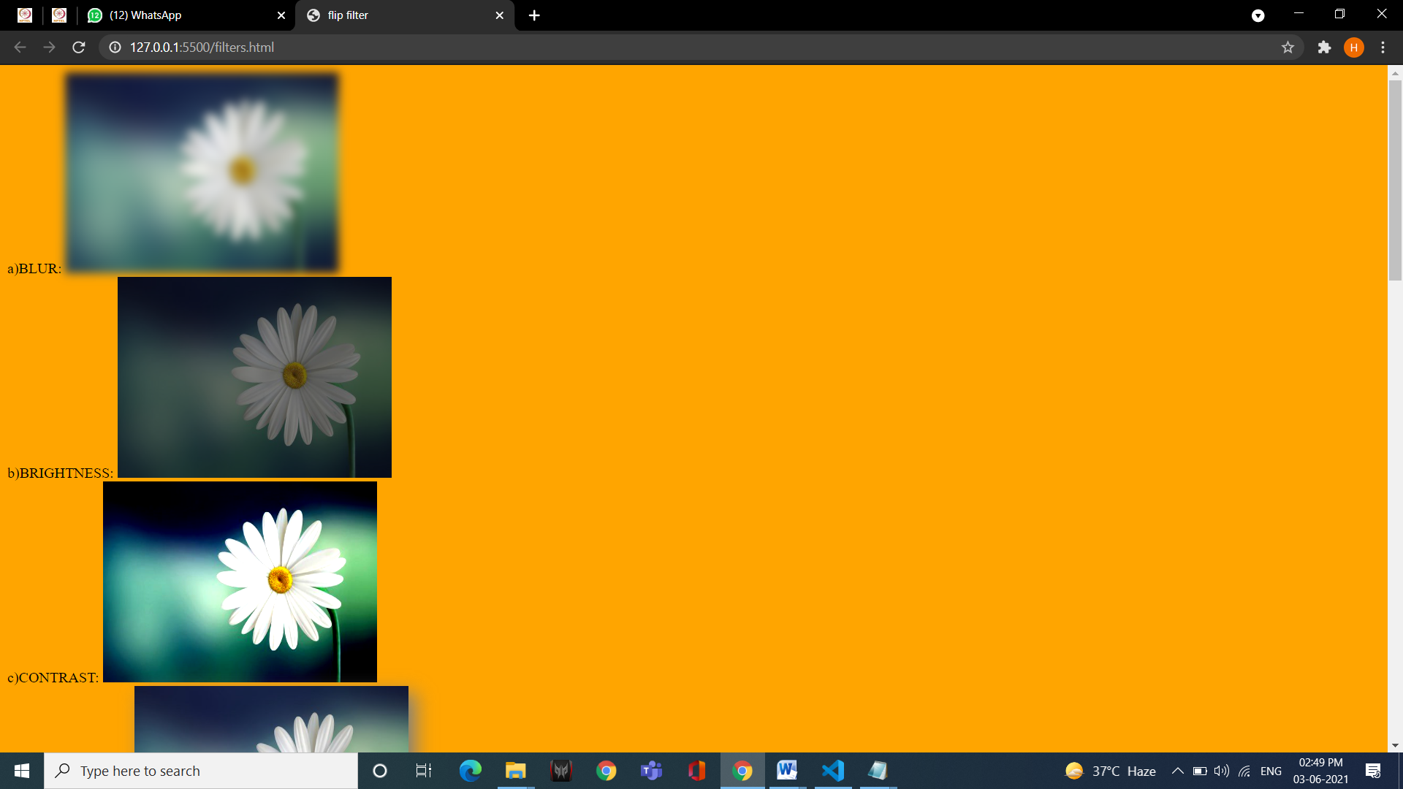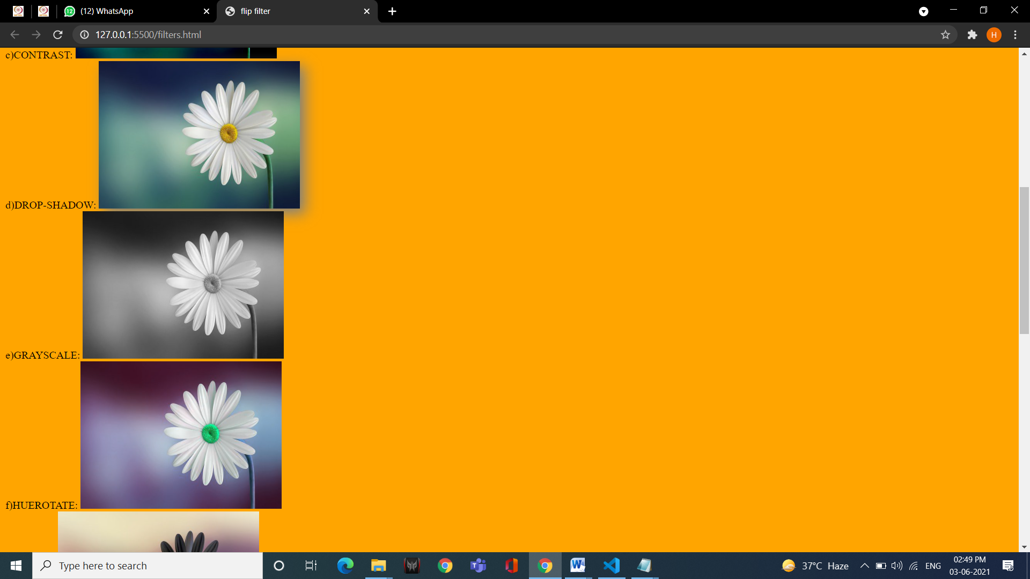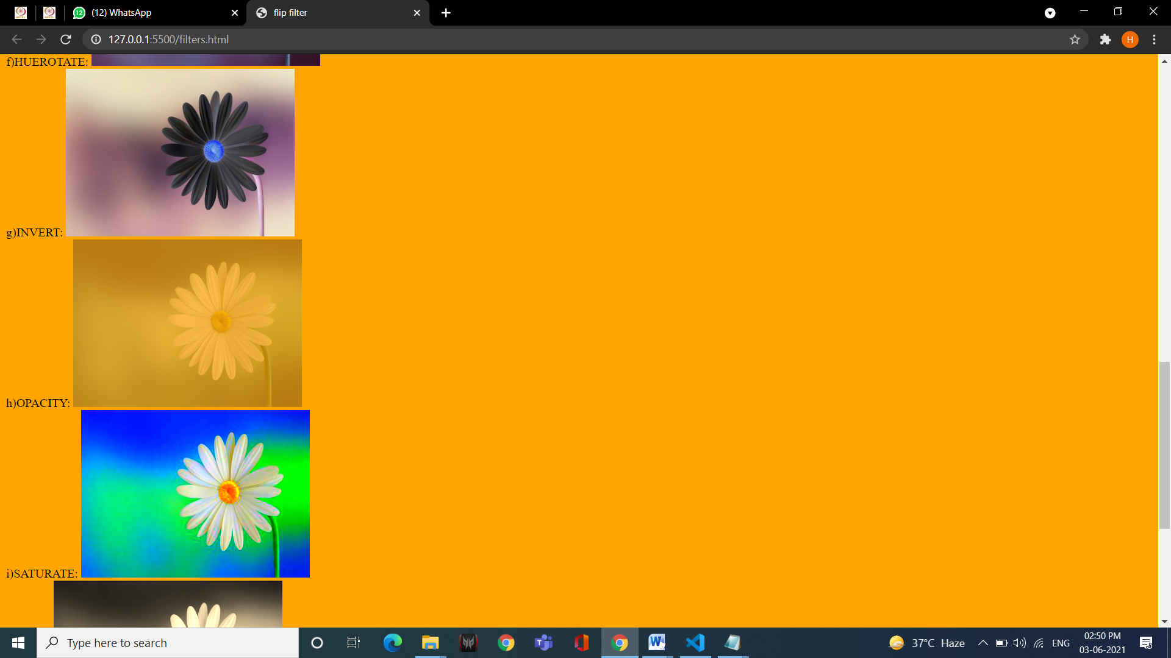

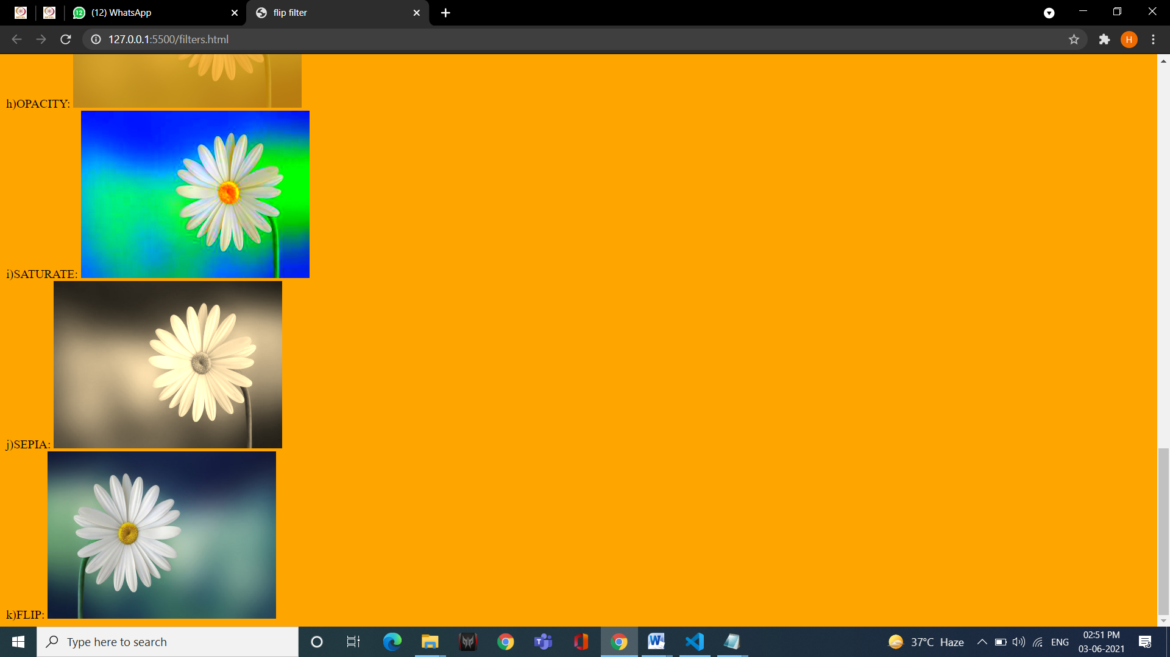**33. Write the code for placing different elements on webpage using static and fixed positioning.**

<!DOCTYPE html>

<html lang="en">

<head>

<title>Document</title>

<style>

#fix{

position: fixed;

border: 5PX solid RED;

}

#stat{

position: static;

width: auto;

border: 5PX solid green;

}

</style>

</head>

<body>

<p id="fix">

fixed position

</p>

<br><br><br><br><br><br><br><br><br><br><br><br><br><br><br><br><br>

<br><br><br><br><br><br><br><br><br><br><br><br><br><br><br><br><br>

<br><br><br><br><br><br><br><br><br><br><br><br><br><br><br><br><br>

<p id="stat">

static position

</p>

<br><br><br><br><br><br><br><br><br><br><br><br><br><br><br><br><br>

<br><br><br><br><br><br><br><br><br><br><br><br><br><br><br><br><br>

</body>

</html>

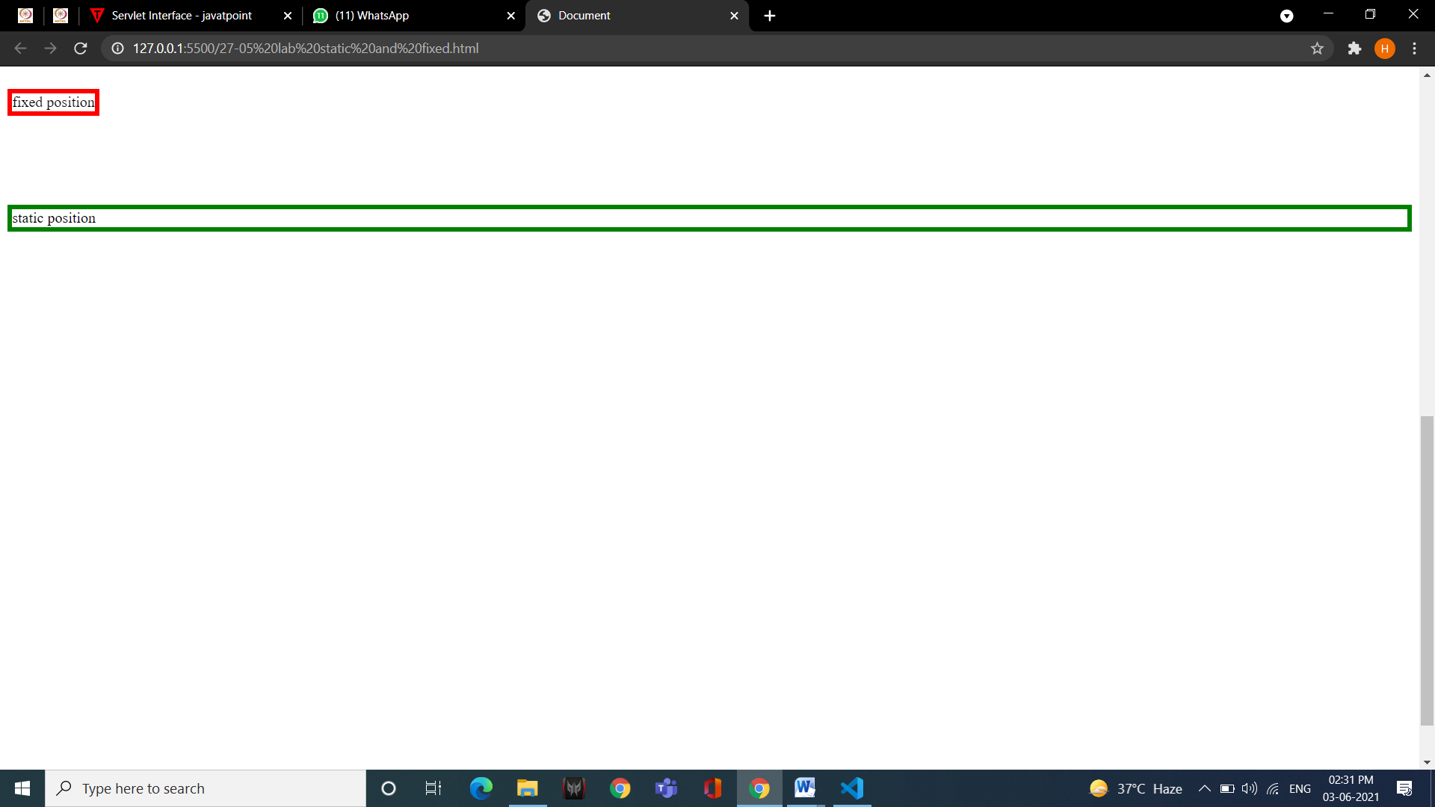

**34.** **Write the code for placing different elements on webpage using absolute and relative positioning.**

<!DOCTYPE html>

<html lang="en">

<head>

<title>Document</title>

<style>

#abs{

border: 5px solid red;

position: absolute;

left: 50px;

}

#rel{

border: 5px solid green;

position: relative;

left: 50px;

top: 150px;

}

</style>

</head>

<body>

<p id="abs">

absolute position

</p>

<p id="rel">

relative position

</p>

</body>

</html>

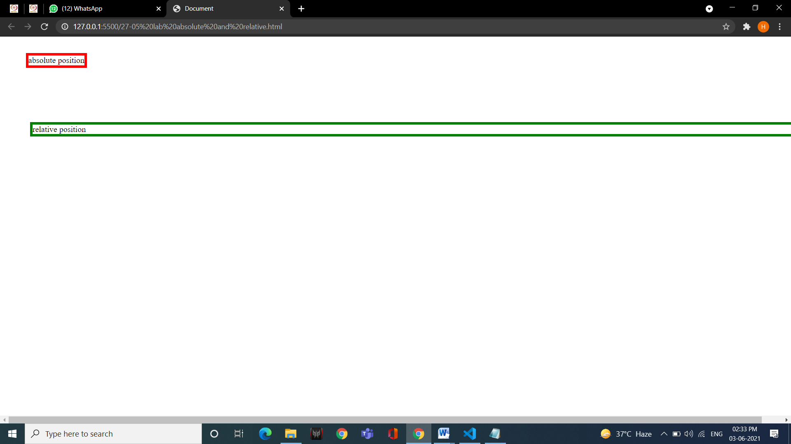

**35.** **Create a webpage to implement ‘this’ keyword for changing the color of heading at run- time.**

<!DOCTYPE html>

<html lang="en">

<head>

<title>Document</title>

</head>

<body>

<h1 id="heading"> Demo heading</h1>

<input type="button" value="CLick me to change color" onclick="func()">

<script>

var col= "red";

function func()

{

document.getElementById("heading").style.color= this.col;

}

</script>

</body>

</html>

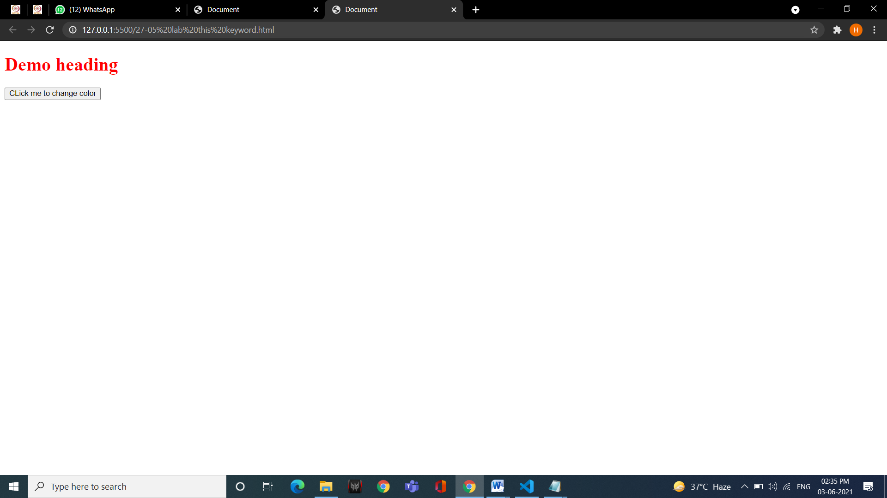

**36. Write a program to change heading color and display a list at run time based on onclick event.**

<!DOCTYPE html>

<html lang="en">

<head>

<title>Document</title>

</head>

<body>

<h1 id="heading"> Demo heading</h1>

<input type="button" value="CLick me to change color and print list" onclick="func()">

<p id="list"></p>

<script>

function func()

{

document.getElementById("heading").style.color= "red";

document.getElementById("list").innerHTML="<ol> <li> item 1</li> <li> item 2</li> <li> item 3</li> </ol>";

}

</script>

</body>

</html>

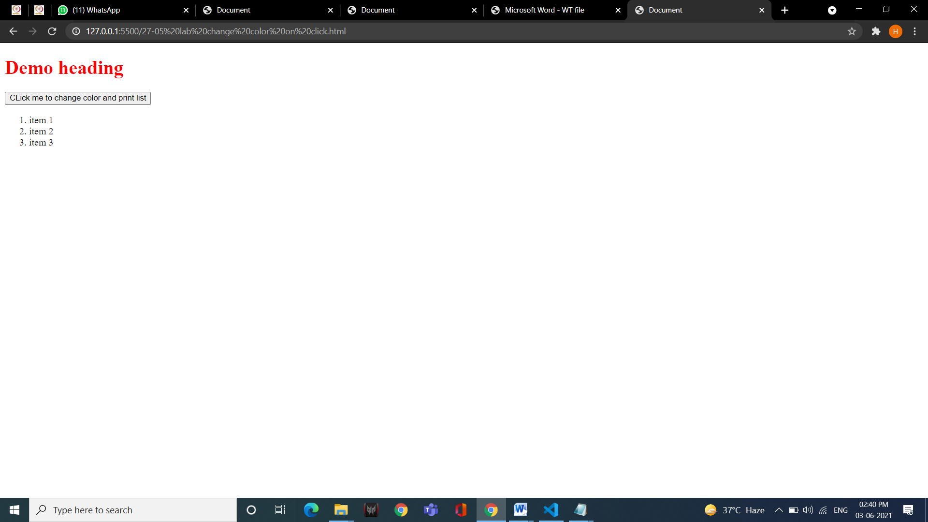

**37. Create a webpage displaying the usage of Image Rollover effect by making use of Id.**

<!DOCTYPE html>

<html lang="en">

<head>

<title>Document</title>

<style>

#image:hover {

content: url('scripting/html.png');

}

</style>

</head>

<body>

<img src="scripting/java.png" id="image">

</body>

</html>

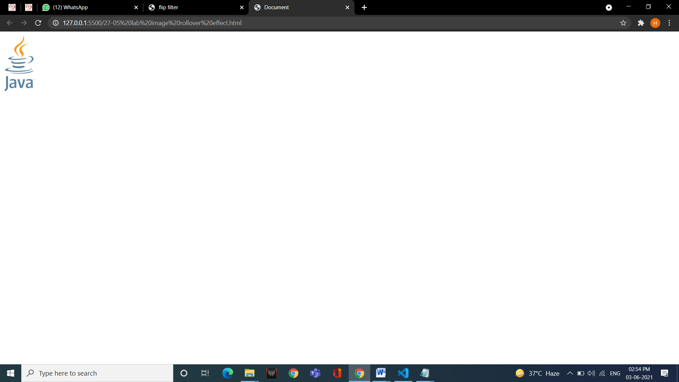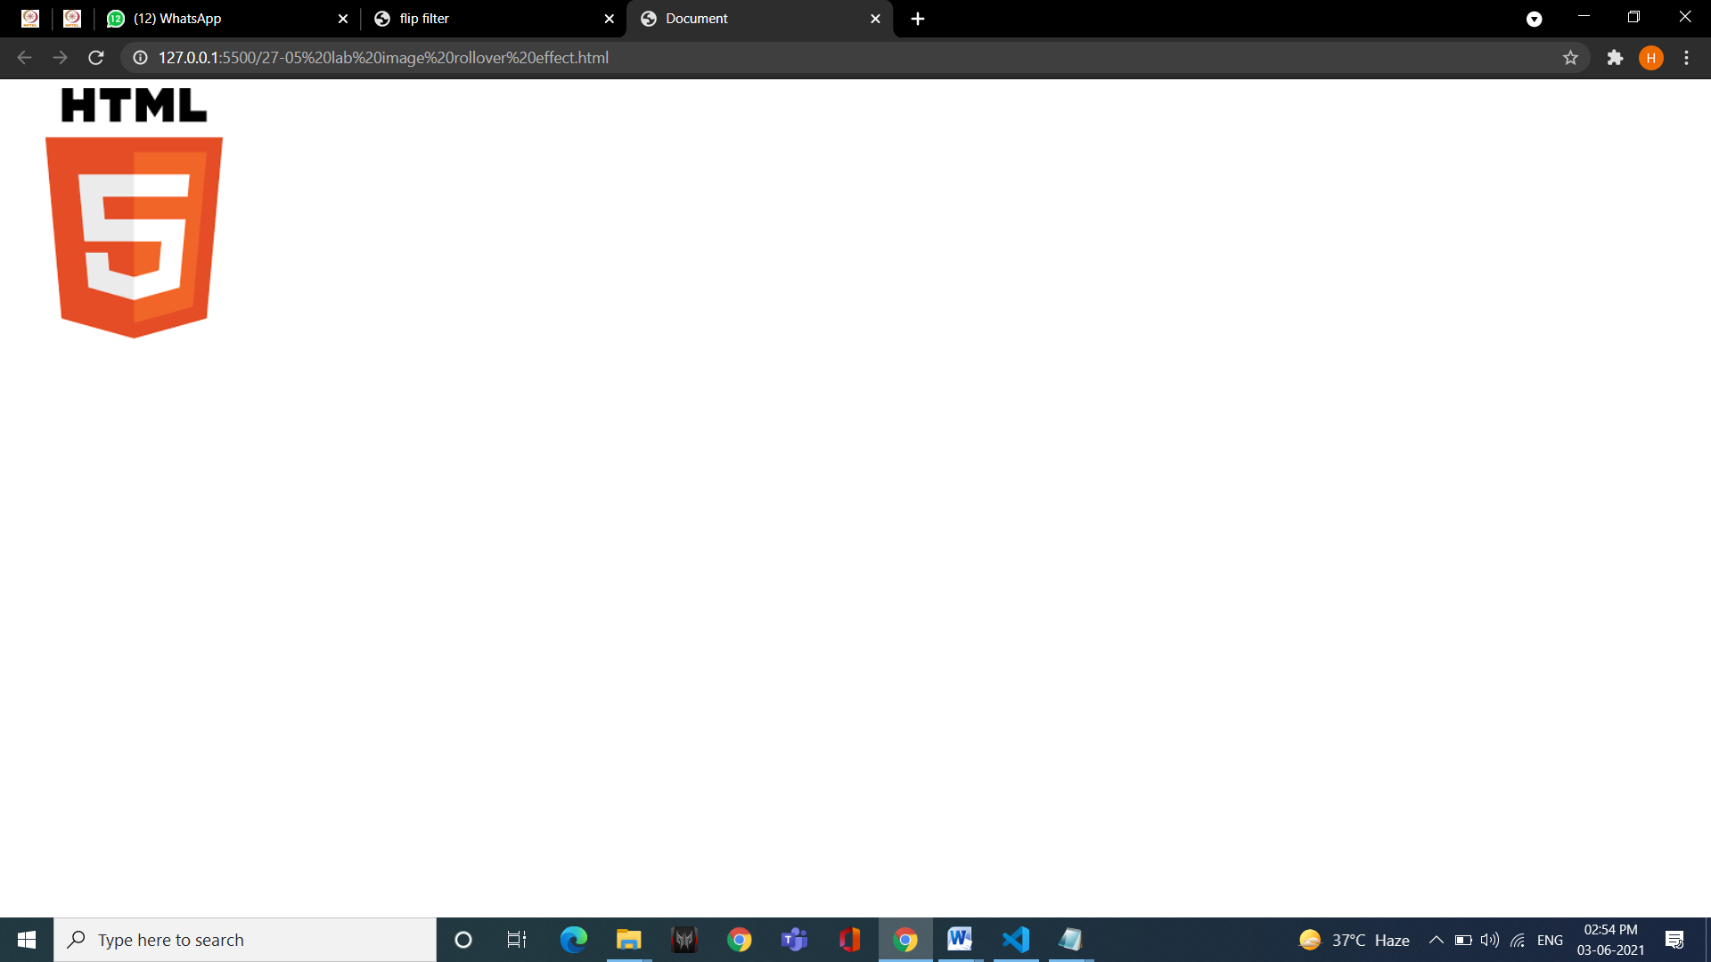

**38. Create a webpage to apply different presentation effects using blend transition.**

<!doctype html>

<html>

<head>

<title>Blend Transition</title>

<style>

.img02 {position:absolute; left:50; top:50; width:300px; filter:blendTrans(duration=4); z-index:1;}

.img01 {position:absolute; left:50; top:50; width:300px; filter:blendTrans(duration=4); z-index:2;}

body {background-color:lightblue;}

</style>

</head>

<body onload="blend()">

<img id="img02" src="lanterns.jpg" onfilterchange="reBlend(false)">

<img id="img01" src="skycandle.jpg" onfilterchange="reBlend(true)">

<script>

<!--

var whichImage=true;

function blend(){

if(whichImage){

img01.filters.blendTrans.apply();

img01.style.visibility="hidden";

img01.filters.blendTrans.play();

}

else{

img02.filters.blendTrans.apply();

img02.style.visibility="hidden";

img02.filters.blendTrans.play();

}

}

function reBlend(fromImage){

if(fromImage){

img01.style.zIndex -=2;

img01.style.visibility="visibile";

}

else{

img01.style.zIndex +=2;

img02.style.visibility="visibile";

}

whichImage=!whichImage;

blend();

}//-->

</script>

</body>

</html>

**39. Create a webpage to apply different presentation effects using reveal transition.**

<!DOCTYPE html >

<HTML>

<HEAD>

<TITLE>Reveal transition</TITLE>

<SCRIPT>

var transitionName = ["Box In", "Circle Out", "Wipe Up", "Vertical Blinds"];

var counter = 0;

var whichImage = true;

function blend()

{

if ( whichImage ) {

image1.filters( "revealTrans" ).apply();

image1.style.visibility = "hidden";

image1.filters( "revealTrans" ).play();

}

else {

image2.filters( "revealTrans" ).apply();

image2.style.visibility = "hidden";

image2.filters( "revealTrans" ).play();

}

}

function reBlend( fromImage )

{

counter++;

if ( fromImage ) {

image1.style.zIndex -= 2;

image1.style.visibility = "visible";

image2.filters("revealTrans").transition = counter % 4;

}

else {

image1.style.zIndex += 2;

image2.style.visibility = "visible";

image1.filters("revealTrans").transition = counter % 4;

}

whichImage = !whichImage;

blend();

transitionDisplay.innerHTML = "Transition " + counter % 4 +

":<BR> " + transitionName[ counter % 4 ];

}

</SCRIPT>

</HEAD>

<BODY STYLE = "color: white; background-color: lightcoral" ONLOAD = "blend()">

<IMG ID = "image2" SRC = "minions.jpg" STYLE = "position: absolute; left: 10; top: 10;

width: 300; z-index:1; visibility: visible; filter: revealTrans( duration = 2, transition = 0 )"

ONFILTERCHANGE = "reBlend( false )">

<IMG ID = "image1" SRC = "minions2.jpg" STYLE = "position: absolute; left: 10; top: 10;

width: 300; z-index:1; visibility: visible; filter: revealTrans( duration = 2, transition = 0 )"

ONFILTERCHANGE = "reBlend( true )">

<DIV ID = "transitionDisplay" STYLE = "position: absolute;

top: 10; left: 325">Transition 0:<BR> Box In</DIV>

</BODY>

</HTML>

**40. Create a webpage displaying the usage of DOM properties: InnerText & OuterText.**

<!DOCTYPE html>

<html lang="en">

<head>

<title>Document</title>

</head>

<body>

<h1 id="inner"></h1>

<h1 id="outer"></h1>

<script>

document.getElementById("inner").innerHTML= "This is Innerhtml heading";

document.getElementById("outer").outerHTML= "This is Outerhtml heading";

</script>

</body>

</html>

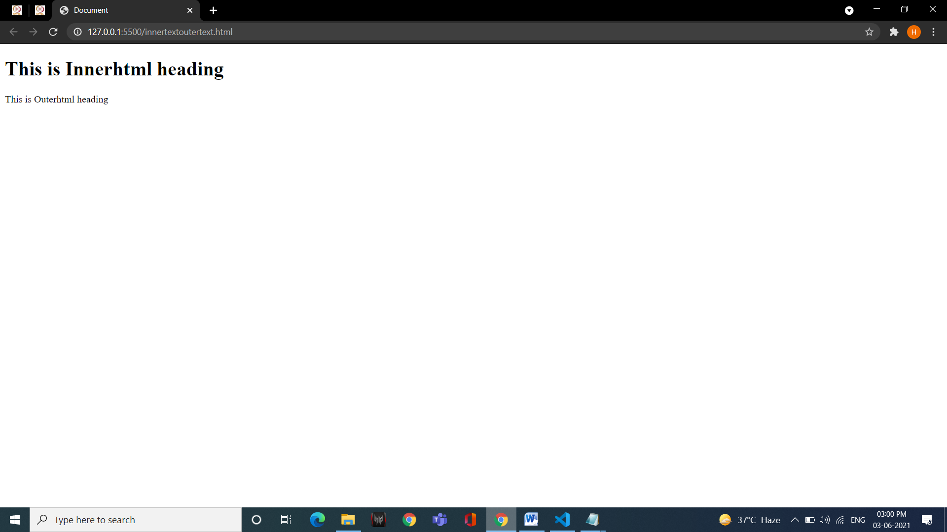

**41. Create an XML file containing note as the root element and to, from, subject and body as its child** **element.**

<?xml version="1.0" encoding="UTF-8"?>

<note>

<to> MSI, Delhi </to>

<from> Harshit Sharma </from>

<subject> Request to get our wednesday holiday back </subject>

<body> Dear Teachers , as a student of prefinal year i would have to work upon my skills to get a better placement next year but in regular days during classes it is not possible to work upon my skills and take classes at the same time so it will be very kind of you if you give as wednesday back so that we can improve our skills, thanking you in advance. </body>

</note>

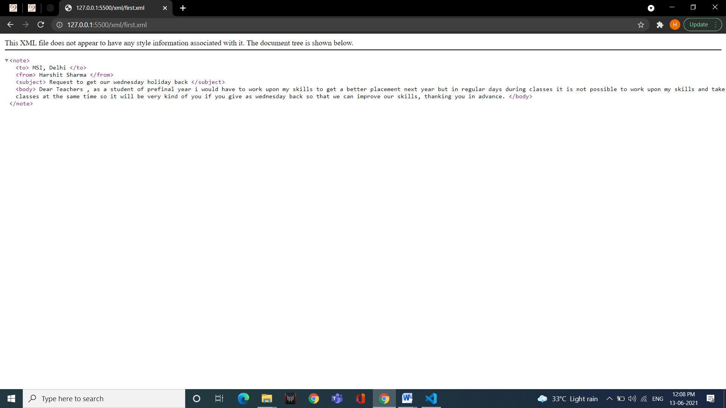

**42. Create a well -formed XML file having 5 tags- food_menu, category, name, price and calories. Food_menu is the main parent element that contains category as the child element. Category is the parent element of name, price and calories.**

<?xml version="1.0" encoding="UTF-8"?>

<food_menu>

<category>

<name> samosa </name>

<price> 15 </price>

<calories>200</calories>

</category>

</food_menu>

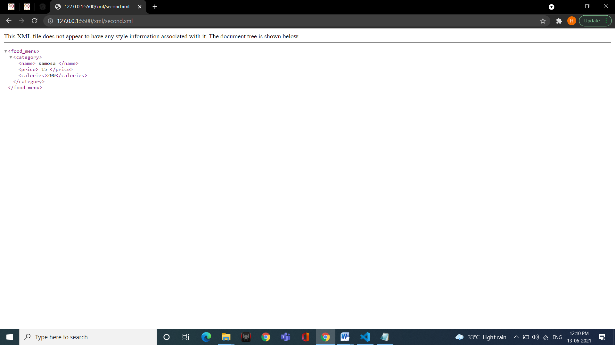

**43. Create a valid XML document containing the tags mentioned in the 41st question (use internal DTD).**

<?xml version="1.0" encoding="UTF-8"?>

<!DOCTYPE note [

<!ELEMENT note (to,from,subject,body)>

<!ELEMENT to (#PCDATA)>

<!ELEMENT from (#PCDATA)>

<!ELEMENT subject (#PCDATA)>

<!ELEMENT body (#PCDATA)>

]>

<note>

<to> MSI, Delhi </to>

<from> Harshit Sharma </from>

<subject> Request to get our wednesday holiday back </subject>

<body> Dear Teachers , as a student of prefinal year i would have to work upon my skills to get a better placement next year but in regular days during classes it is not possible to work upon my skills and take classes at the same time so it will be very kind of you if you give as wednesday back so that we can improve our skills, thanking you in advance. </body>

</note>



**44. Create a valid XML document containing employee as the root tag and empname, empno, salary, department as its child tags. Use external DTD to implement it.**

**XML**-

<?xml version="1.0" encoding="UTF-8"?>

<!DOCTYPE employee SYSTEM "forth.dtd">

<employee>

<empname>Harshit</empname>

<empno> 03621202019 </empno>

<salary> 100000</salary>

<dept> BCA </dept>

</employee>

**DTD –**

<!ELEMENT employee (empname,empno,salary,dept)>

<!ELEMENT empname (#PCDATA)>

<!ELEMENT empno (#PCDATA)>

<!ELEMENT salary (#PCDATA)>

<!ELEMENT dept (#PCDATA)>

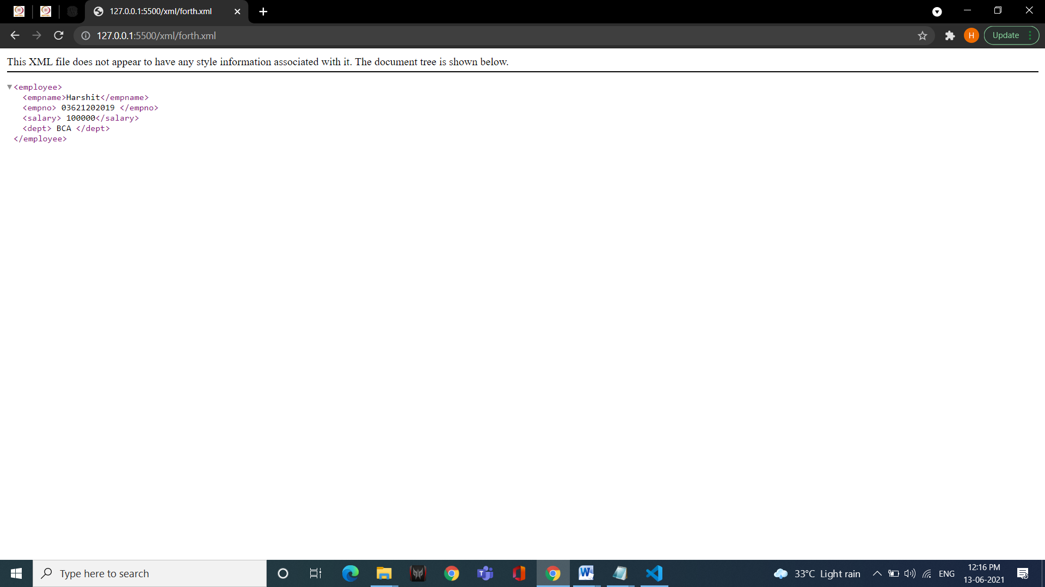

**45. Create an XML file and use external style sheet for providing styling to XML file. Each element should use at least 4 styling attributes.**

**XML-**

<?xml version="1.0" encoding="UTF-8"?>

<?xml-stylesheet type="text/xsl" href="style.xsl"?>

<food_menu>

<name> Pizza </name>

<price> 150 </price>

<calories>800</calories>

</category>

<category>

<name> something eatable </name>

<price> 350 </price>

<calories>2850</calories>

</category>

<category>

<name> chole bhature </name>

<price> 75 </price>

<calories>800</calories>

</category>

</food_menu>

**XSL-**

<?xml version="1.0" encoding="UTF-8"?>

<xsl:stylesheet version="1.0" xmlns:xsl="http://www.w3.org/1999/XSL/Transform">

<xsl:template match="/">

<html>

<body>

<h2>FOOD MENU</h2>

<table border="1">

<tr bgcolor="yellow">

<th>Name</th>

<th>Price</th>

<th>calories</th>

</tr>

<xsl:for-each select="food_menu/category">

<tr>

<td><xsl:value-of select="name"/></td>

<td><xsl:value-of select="price"/></td>

<td><xsl:value-of select="calories"/></td>

</tr>

</xsl:for-each>

</table>

</body>

</html>

</xsl:template>

</xsl:stylesheet>

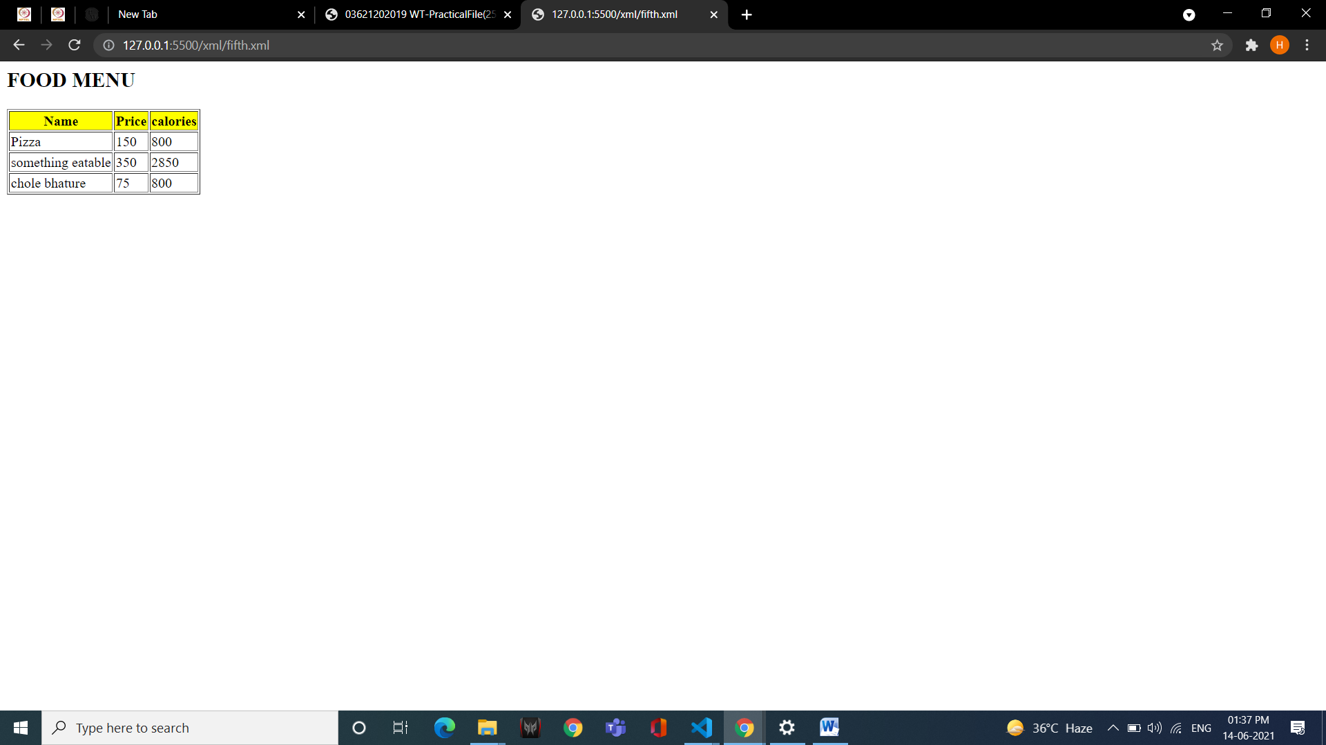

**46. Create an XML program containing book information and also create its XSL document include sorting feature.**

**XML-**

<?xml version="1.0" encoding="UTF-8"?>

<?xml-stylesheet type="text/xsl" href="style_books.xsl"?>

<Books>

<category >

<name> Hari putra </name>

<author> Dr. Jai Kishan Prashad ( J.K Prashad) </author>

<price> 1500 </price>

</category>

<category >

<name> The Da Vinchi Code </name>

<author> Miss. Mona Lisa </author>

<price> 1299 </price>

</category>

<category >

<name> The Story of My Life </name>

<author> Mr. Kamlesh Sulochan </author>

<price> 1021 </price>

</category>

</Books>

**XSL-**

<?xml version="1.0" encoding="UTF-8"?>

<xsl:stylesheet version="1.0" xmlns:xsl="http://www.w3.org/1999/XSL/Transform">

<xsl:template match="/">

<html>

<body>

<h1>Books List</h1>

<table border="5px">

<tr bgcolor="yellow">

<th>Name</th>

<th>Author</th>

<th>Price</th>

</tr>

<xsl:for-each select="Books/category">

<xsl:sort select="price"/>

<tr>

<td><xsl:value-of select="name"/></td>

<td><xsl:value-of select="author"/></td>

<td><xsl:value-of select="price"/></td>

</tr>

</xsl:for-each>

</table>

</body>

</html>

</xsl:template>

</xsl:stylesheet>

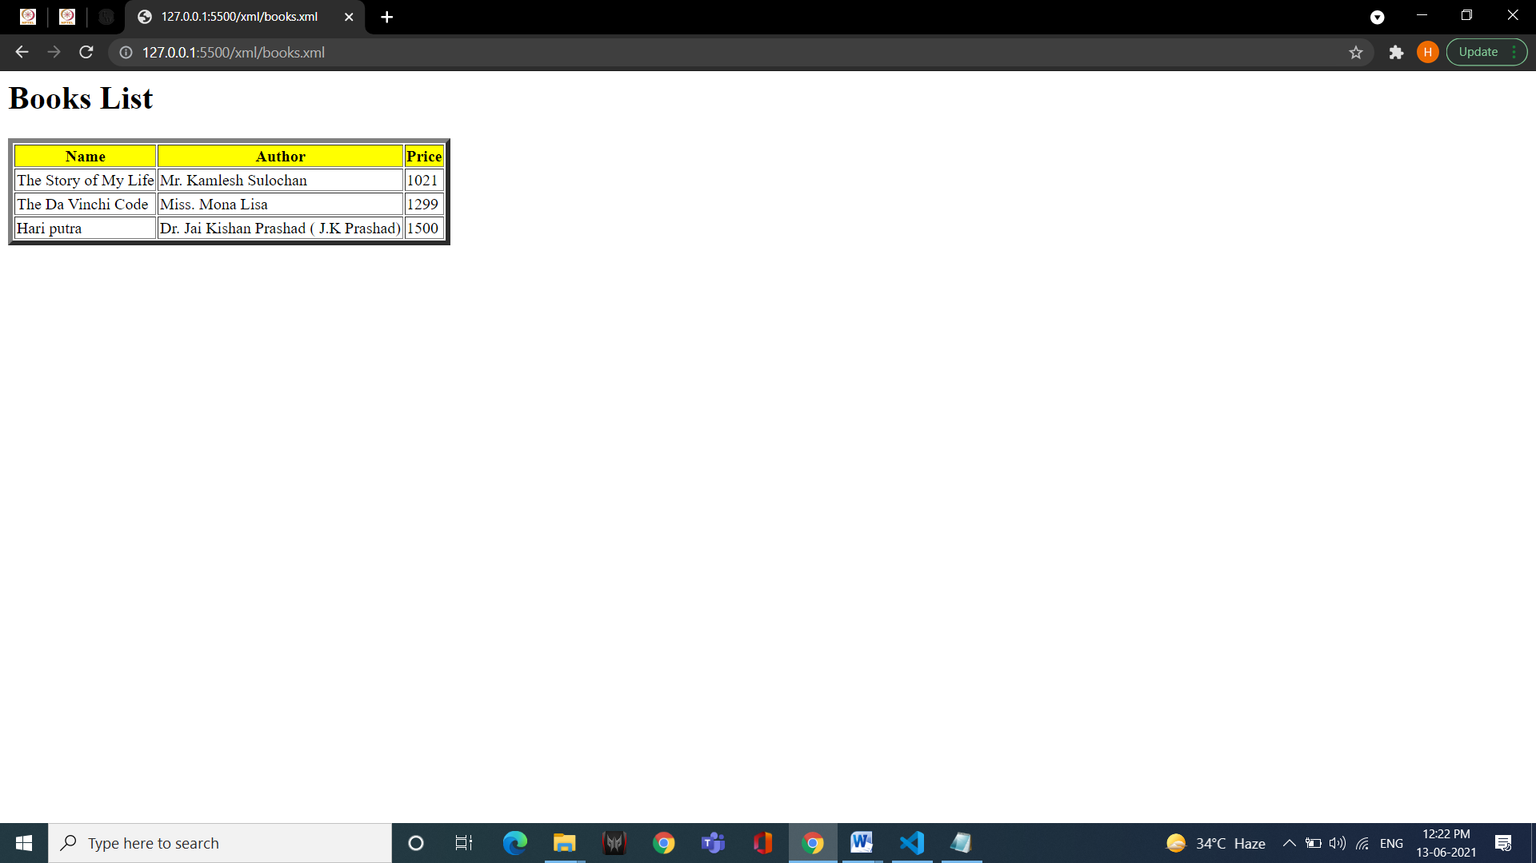

**47. Create XML file in the given format:**

**<cart>**

**<product>**

**<pname> Notebook </pname>**

**<cost> 50 </cost>**

**<discount> 10 </discount>**

**</product>**

**<product>**

**<pname> PenSet </pname>**

**<cost> 150 </cost>**

**<discount> 50 </discount>**

**</product>**

**</cart>**

**Using XSLT display the XML data in the table format, choose different color of product above 100 and below 100.**

**XML-**

<?xml version="1.0" encoding="UTF-8"?>

<!DOCTYPE employee SYSTEM "prog1.dtd">

<?xml-stylesheet type="text/xsl" href="cart_styl.xsl"?>

<cart>

<product>

<pname> Notebook </pname>

<price> 50 </price>

<discount>10 </discount>

</product>

<product>

<pname> Penset</pname>

<price> 150 </price>

<discount> 50 </discount>

</product>

</cart>

**­XSL-**

<?xml version="1.0" encoding="UTF-8"?>

<xsl:stylesheet version="1.0" xmlns:xsl="http://www.w3.org/1999/XSL/Transform">

<xsl:template match="/">

<html>

<body>

<h1>Cart</h1>

<table border="5px">

<tr bgcolor="yellow">

<th>Name</th>

<th>Price</th>

<th>Discount</th>

</tr>

<xsl:for-each select="cart/product">

<tr>

<td><xsl:value-of select="pname"/></td>

<xsl:if test="price &gt; 100">

<td bgcolor="#5cd65c"><xsl:value-of select="price"/></td>

</xsl:if>

<xsl:if test="price &lt; 100">

<td bgcolor="#ffe6b3"><xsl:value-of select="price"/></td>

</xsl:if>

<td><xsl:value-of select="discount"/></td>

</tr>

</xsl:for-each>

</table>

</body>

</html>

</xsl:template>

</xsl:stylesheet>

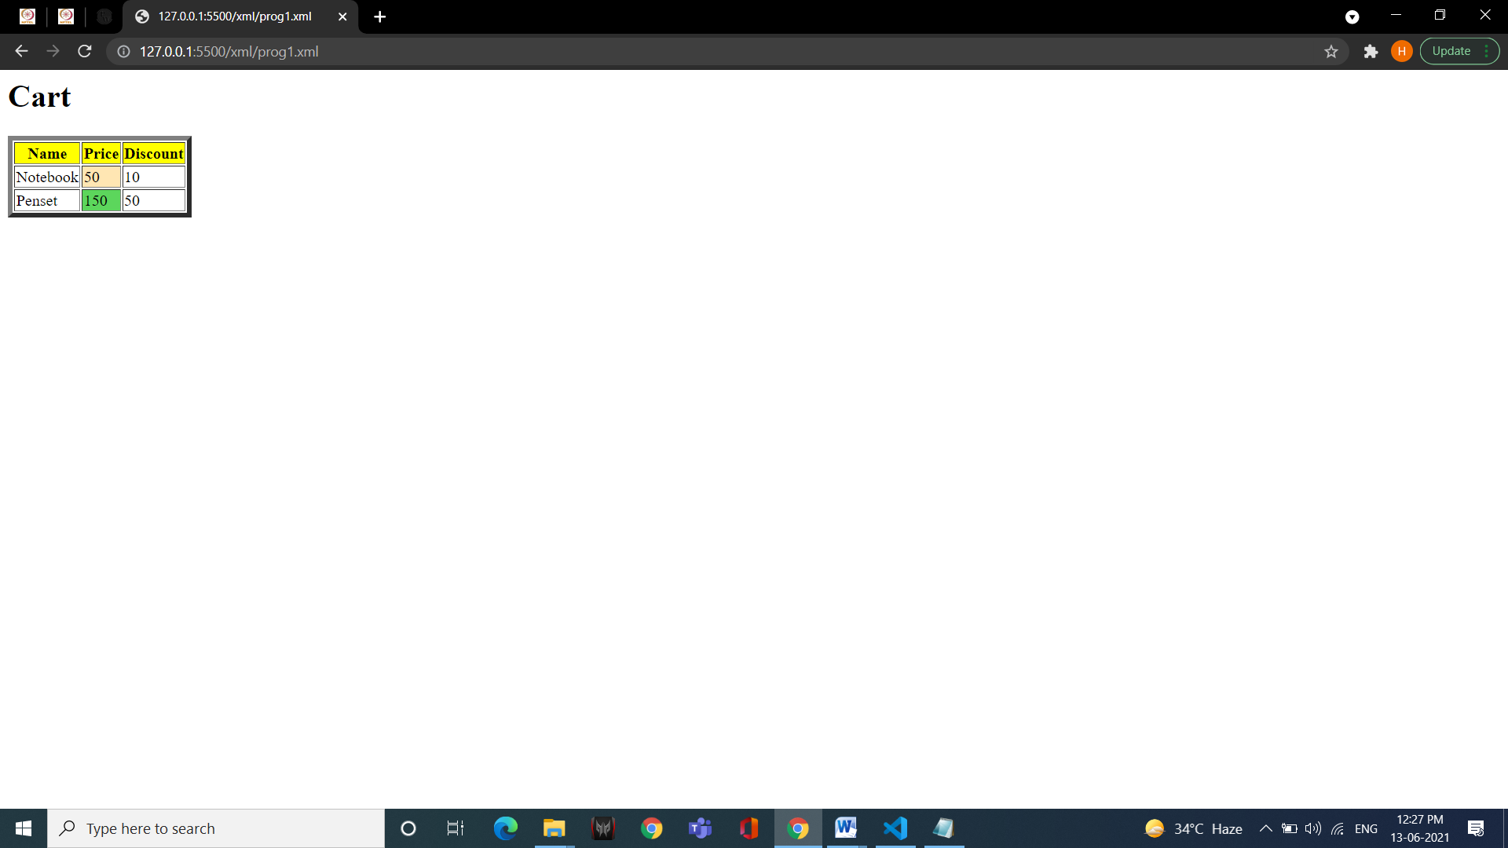

**48. Create a DTD for the above XML file and Validate the XML in validator.**

<!DOCTYPE cart [

<!ELEMENT product (pname, price , discount)>

<!ELEMENT pname (#PCDATA)>

<!ELEMENT price (#PCDATA)>

<!ELEMENT discount (#PCDATA)>

]>

**49. Write an XML program to accept student details (name, ID, course, CGPA). Write an XSL to display the list of students in descending order of CGPA.**

**XML-**

<?xml version="1.0" encoding="UTF-8"?>

<?xml-stylesheet type="text/xsl" href="stu.xsl"?>

<Admin>

<Student>

<name> Harshit </name>

<id> 036 </id>

<course> BCA </course>

<CGPA> 9.2 </CGPA>

</Student>

<Student>

<name> Abhishek </name>

<id> 045 </id>

<course> BCA </course>

<CGPA> 8.4 </CGPA>

</Student>

<Student>

<name> Surbhi </name>

<id> 001 </id>

<course> BCA </course>

<CGPA> 9.9 </CGPA>

</Student>

<Student>

<name> Avinash </name>

<id> 002 </id>

<course> BCA </course>

<CGPA> 9.0 </CGPA>

</Student>

<Student>

<name> Sneha </name>

<id> 039 </id>

<course> BCA </course>

<CGPA> 9.8 </CGPA>

</Student>

</Admin>

**XSL-**

<?xml version="1.0" encoding="UTF-8"?>

<xsl:stylesheet version="1.0" xmlns:xsl="http://www.w3.org/1999/XSL/Transform">

<xsl:template match="/">

<html>

<body>

<h2>Students List</h2>

<table border="5">

<tr bgcolor="yellow">

<th>Name</th>

<th>ID</th>

<th>Course</th>

<th>CGPA</th>

</tr>

<xsl:for-each select="Admin/Student">

<xsl:sort select="CGPA" order="descending"/>

<tr>

<td><xsl:value-of select="name"/></td>

<td><xsl:value-of select="id"/></td>

<td><xsl:value-of select="course"/></td>

<td><xsl:value-of select="CGPA"/></td>

</tr>

</xsl:for-each>

</table>

</body>

</html>

</xsl:template>

</xsl:stylesheet>

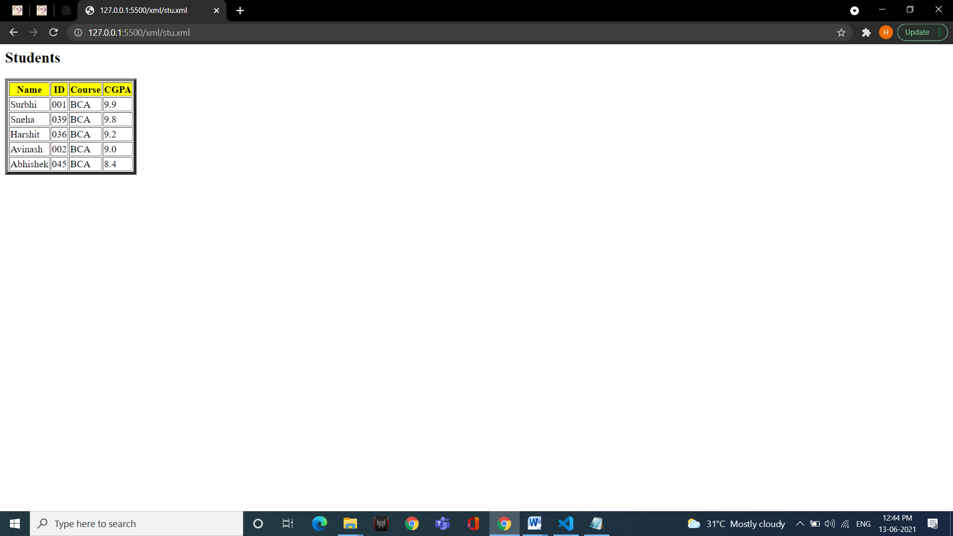

**50. Create an external DTD for XML file mentioned in 42nd ques.**

<!DOCTYPE food_menu [

<!ELEMENT category (name, price , calories)>

<!ELEMENT name (#PCDATA)>

<!ELEMENT price (#PCDATA)>

<!ELEMENT calories (#PCDATA)>

]>